WAR MEMORIES

The German War Memories of Wiebe Feenstra,
born November 2 1928 in Lemmer, Friesland, Netherlands
Composed from written notes made by him during this period.

May 1940 - April 1945

Notes in [brackets] are from the typist - Thor Carden, as is any text in boxes such as this one. I entered Wiebe's typewritten notes into a Microsoft Word document from 20 typed pages, double sided. The translator was apparently not a native English speaker. There were some charming oddities as a result. (For instance, using the word controlled when arrested is what is meant. Or except when accept is meant.) I corrected these when I understood them, but I probably added some mistakes of my own. I also inserted some illustrations and explanations from stuff I found on the internet. I took the liberty of breaking some of the longer passages into paragraphs to enhance readability. I believe many of the notes in (parenthesis) were added at the time of translation but perhaps not.

I also anglicized some of the names to make for easier reading:
Andy instead of Anne
Frank instead of Franke
George instead of Cor
Greta instead of Grada
Jim instead of Jilling
Luke instead of Leeuwke
Minnie instead of Minne
Paul instead of Poppe
Peter instead of Pieter
Rita instead of Rina
Jake instead of Sake
William instead of Willem

TABLE OF CONTENTS
(by segment and date)

War Memories 1 (May 10, 1940 - May 11, 1940) 5
War Memories 2 (May 12, 1940 - May 14, 1940) 8
War Memories 3 (June 6, 1940 - July 27, 1940) 9
War Memories 4 (July 27, 1940 - August 31, 1940) 11
War Memories 5 (September 23, 1940 - December 31, 1940) 13
War Memories 6 (December 31, 1940 - June 22, 1941) 15
War Memories 7 (July 17, 1941 - November 1, 1941) 16
War Memories 8 (November 1, 1941 - June 26, 1942) 18
War Memories 9 (July 4, 1942 - December 31, 1942) 20
War Memories 10 (December 31, 1942 - Janurary 21, 1943) 22
War Memories 11 (January 27, 1943 - April 14, 1943) 24
War Memories 12 (May 4, 1943 - June 12, 1943) 26
War Memories 13 (June 12, 1943 - August 8, 1943) 28
War Memories 14 (October 26, 1943 - November 26, 1943) 31
War Memories 15 (November 26, 1943 - December 31, 1943) 33
War Memories 16 (December 31, 1943 - January 7, 1944) 36
War Memories 17 (January 25, 1944 - June 8, 1944) 38
War Memories 18 (August 5, 1944 - September 8, 1944) 40
War Memories 19 (September 8, 1944 - October 7, 1944) 42
War Memories 20 (October 7, 1944 - October 28, 1944) 44
War Memories 21 (October 28, 1944 - November 17, 1944) 48
War Memories 22 (November 17, 1944 - November 25, 1944) 50
War Memories 23 (December 14, 1944 - December 23, 1944) 52
War Memories 24 (December 25, 1944 - January 13, 1945) 54
War Memories 25 (January 13, 1945 - March 19, 1945) 56
War Memories 26 (March 19, 1945 - March 23, 1945) 58
War Memories 27 (March 23, 1945 - April 4, 1945) 60
War Memories 28 (April 4, 1945 - April 14, 1945) 62
War Memories 29 (April 15, 1945 - April 16, 1945) 64
War Memories 30 (April 16, 1945 - April 17, 1945) 66
War Memories 31 (April 17, 1945) 68
War Memories 32 (April 18, 1945) 70

War Chronologies
1939 14
1940 14
1941 19
1942 23
1943 37
1944 55
1945 71

TABLE OF CONTENTS
(by year and events)

1940
War is coming! Dump the alcohol. Jews try to escape. [Map of Zuider Sea] 5
The Germans arrive in Lemmer 6
[Map of Netherlands] 7
Many Germans passing through, war news, bombing of Rotterdam, surrender 8
Concern for Cousin Jake, [Grebbe Line] 9
A journey to Nijmegen, Harbor is attacked 10
Officer Dirksen, Jake comes home, Schnellbotes 11
The wearing of the Orange [How Orange is Linked to the Netherlands] 12
Gun emplacements, Dutch underground active, candy from the RAF 13
Bleak outlook, rationing, ID cards 14
Anti-aircraft practice 15

1941
Searchlight destroyed, Dutch Nazi, air raids on Germany, Russia attacked 15
Soldiers in fur boots, mysterious books, pilot buried, rumor of Dieppe allied invasion 16
Another attack on the harbor by Spitfires, air war shakes house [Nachtjagd] 17
Exploring bomb craters, Pearl Harbor, V for victory, general strike 18

1942
General strike, odd German installation [radar?] 18
Harassment of Jews, airplanes heard and felt but not seen 19
Busy night in the air, homing pigeons banned [War pigeons] 20
Two ferry attacks, Uncle Feite wounded, Germans steal church bells,
Paul de Rook and the "light bullet." 21
The boys set off the "light bullet" and run, war outlook still bleak 22

1943
A hiding place for Jan Nicolai 23
Bombing causes school evacuation, American planes sighted, friend's father is arrested 24
German airplane crashes, General strike [Map of Friesland] 25
Honest fisherman killed, wireless radios confiscated, The Flying Dutchman 26
Exploring a crash site 27
More about crash site, mysterious metal strips - radar countermeasure? [Chaff] 28
Bloated body surprise for Uncle Luke 30
Mother cleans house during bombing, ID card, B-24 emergency landing 31
Midday air battle, Germans machine gun parachutists 32
Mysterious balloons [Operation OUTWARD] 33
Fire ball from the sky, exploring the crash site in fog, a startling rifle shot,
conversation with German soldiers, reflections on another year of war 35
More reflections, a better outlook than before, German overlooks bread 36
TABLE OF CONTENTS
(by year and events continued)

1944
Dad trips the bell wire at anti-aircraft gun 36
Thunderbolts hunt for targets, and V-1 38
More Thunderbolt and tour of a FLAK-boat, US enters war, odd trenches 39
Train attacked, FLAK boat hits Spitfire, curfew, Uncle Harry and Aunt Anna 40
German friends flee east, pillboxes in the park 41
Mine fields, rumors of allied paratroopers, V2 42
Bartering with salt [History of salt] 43
Encounter with police, more V-2's, trip for tobacco 44
Girls from Amsterdam scavenging for food, [The Starvation Winter in Amsterdam] 45
House guests from Amsterdam, an unplanned swim, Typhoons fly over 48
Typhoons attack anti aircraft gun, son of NSB member, [NSB] 49
Jan fools Grolleman, more air attacks, lost in a fog 50
Jim pilots the German boat aground [How the Dutch take farm land from the sea] 51
Visitors from Amsterdam, poacher almost snared 52
A habit of hospitality 53
Christmas celebration, another year of war, oil balls, skin disease 54

1945
The ferry Groningen IV is sunk with loss of life 55
Some ham and bacon, Geri Boon moves to area, Dutch resistance [CS-6] 56
German reprisals, a Polack on the run [Postum Coffee] 57
The Polack escapes, Geri's father visits 58
Mr. Boon catches the ferry home, Feenstra family in Dutch resistance [onderduikers] 59
Stopped by the police while helping the resistance [German Police] 60
The Rhine is crossed, Geri looks for her brother, boat full of hungry children
[Operation Varsity] 61
Children are fed, Geri moves to Feenstra home, Germans on the run
[Operation Amherst] 62
Allied paratroopers in Friesland, rumors of war all around 63
Lemmer filled with Germans, an old soldier gets food & drink 64
Milk run in the middle of war, Dad hooks a horse to a German cart 65
Lemmer is shelled 66
Quiet in the morning, damage reports 67
Germans are gone, more damage reports, Canadian troops arrive 68
Liberated at last [Le Régiment de la Chaudière] 69
Freedom, German warship passes by, collaborators humiliated, new shoes,
fishing with grenades 70
Accident with ammo 71
Epilogue needed 72

WAR MEMORIES 1
1940
Friday May 10th
My mother woke me up early this morning. She told me that German troops had invaded our country and that we were at war with Germany. During the whole night, there had been planes in the air. I had not heard anything. After I was showered and dressed, I went outdoors quickly. In our street people were talking together everywhere. My father talked with our neighbors Prins, de Vries and Heilke. It all seemed very impressive.

My mother did not allow me, but I snuck off to our village center. Dutch soldiers were blowing up the lock gates. Friesland had to be inundated so the Germans could not advance. This is what older people told each other. In the village center many men were talking. Our soldiers have sunk ships in front of the harbor entrance. From the railway bridge, I could see that at least five ships had been sunk. We (in the mean time I had met my friends William Gaasbeek and Jan Tenk) were not allowed to go to the lighthouse on the harbor dam.

When I came home again, mother was busy destroying the leftover wine and other alcoholic beverages, from their 12 1/2 - year wedding anniversary on last April 20th. Mother was afraid that when the Germans ever came to Lemmer, they would search in houses for spirits and when they had drunk the spirits, they would beat every thing to pieces, or even worse. That day many Jewish people came to the harbor of Lemmer. They came from Sneek and Leeuwarden. Some of them even came from Groningen. They asked fishermen of Lemmer if they would take them to the other side of the Ijsselmeer to Amsterdam or Enkhuizen to escape from the Germans. It was told that they offered large amounts of money and even their cars. I do not know if there were fishermen who took the offers.
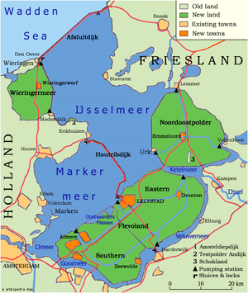 | [Map from the internet  ← LEMMER, Wiebe Feenstra's home.]

Saturday May 11th
I heard in our street, that French soldiers had arrived in Lemmer. The French soldiers will help us beat the Germans. At eleven o'clock this morning I went, as fast as I could go, to the village center to watch the French soldiers. When I arrived at the town hall, I saw a motorcycle and sidecar. Next to the motorcycle stood a soldier. He was dressed in a leather coat and a helmet of a complete different design then the ones of our soldiers. He had a steel weapon hanging in front of his chest. It was a different kind of weapon then the ones of our soldiers. I do not know where our soldiers went. People said that early in the morning they had gone by car. Shortly after this, I heard people near the town hall saying that the soldier was not a Frenchman but that it was a German. There were, in fact, no French soldiers in our street. The rumor had been wrong.

How is it possible that the Germans came to Lemmer so quickly? Could our soldiers not stop these Germans? I do not understand anything. On the radio news this morning, they said that our troops defended us well everywhere, but now the Germans are already here in Lemmer. I do not have answers for any of these questions. Is my cousin Jake, who is a sergeant in the eighth infantry regiment, also running from the Germans? No. That is impossible. Jake is not even afraid of the devil.

In the afternoon, it became even clearer that the Germans are in Lemmer. They arrived in greater numbers. They came in a kind of truck with two wheels in front, and caterpillar tracks on the rear. [half track] Big guns were connected behind those trucks. Most of the Germans, however, came on horses. There were also two horse wagons with a guns towed behind. We are sure now that they are Germans, for they told me so themselves. The Germans gave us handfulls of sweets. When I came home with the sweets, mother ordered me to throw them in the garbage can. Mother thought the sweets might be poisoned. Towards evening Lemmer was crowded with German soldiers. They lodged in the schools. All kinds of military vehicles and tanks were parked in our streets. The soldiers in the open trucks with the big guns behind look terrifying. They have branches with leaves attached to their helmets and black and green stripes painted over their faces.

A kitchen car is parked near our school. The German military cooks prepare food for the other soldiers. The military cooks do not look terrifying or wild. Although we would rather have seen Dutch or French soldiers, it is all together exciting for my friends and me. In the mean time, local carpenters are trying to repair the lock gates so the water already risen in canals and ditches can not rise higher. German sailors are busy tugging away, with the help of a Dutch tugboat, the sunken ships from our harbor entrance. German divers first closed the holes as much as possible, and then pumped the water out.

While doing this job, a few Germans drowned. My mother's brother, a fisherman, was ordered to help with the dragging for the drowned krauts. How those German sailors could be here so soon also beats me. The Germans are cutting off the masts from any fishing boats that have an engine. It is said that those fishing boats will be used to cross to the other side of the Ijsselmeer because they cannot pass the Dutch defenses on the Ijsselmeer dam (causeway) and the Grebbe defenses over land. I heard that some German soldiers think that on the other side of the Ijsselmeer is England. They have not learned very much about geography at school.

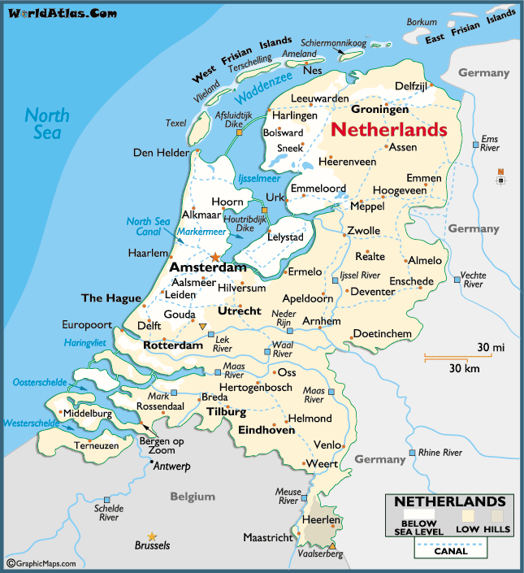
[Jake's home town, Nijmegen, is about 15 or 20 miles south of Arnhem.
Lemmer is about halfway between Sneek and Emmeloord]

WAR MEMORIES 2
[I am guessing that these "war memories #" headings have more to do with running out of room in a tablet page he was using than from any logical break in the narrative.]

1940
Sunday May 12th
Today it is Whit Sunday. [Pentecost - 50 days after Easter] All day long crowds of Germans went through Lemmer. They mainly came from the east. At least 90% of the Germans who passed through today were on horseback. Never before, have I seen so many horses in one day. Not even last August, at the start of the total mobilization, when all healthy horses of Friesland were required by our government to come here to Lemmer. From the south of Lemmer the Germans can not get through anymore, because the bridge over the canal on that side of Lemmer has broken down due to the heavy tanks coming over it. The bridge is out of balance. Only pedestrians and cyclists can still use it.

It is said that the Germans suffer heavy losses near the Ijsselmeer dam and the Dutch drive the Germans backwards again. It could be true, because in and around our village the Germans put heavy guns in position. We all hope it is true. Close by, next to the reformed church, they have put a heavy gun in position too. The gun is camouflaged with tree branches. The barrel is pointed in a northerly direction, which is the direction of the Ijsselmeer dam. Mother has forbidden me to go out on the street. My uncle Peter has preferred the certain to the uncertain, and is going to bed completely dressed. Father has the late shift at his work, so he will not be home before late tonight. My mother and sister Aaltje are worried and afraid. For me it is all only exciting, but I do not dare to tell mother.

Monday May 13th.
After all, we are glad it did not come to action here. However, trucks drove from North to East through Lemmer. People say those trucks are loaded with Germans killed in action. I could not check it, because the backsides of the trucks are covered with tied canvas. They are very big Mercedes Benz trucks. The gun next to the church has been taken away. Father had to laugh when we told him that uncle Peter (his brother) went to bed completely dressed, when he heard that in or near Lemmer there might be combat. After all, we had exaggerated the dressing story somewhat, by telling that uncle Peter kept on his shoes, overcoat and hat. Today, German soldiers on horseback still went through Lemmer. My friends and I were watching the scene from behind some trees.

Tuesday May 14th.
There are still a great number of Germans in Lemmer. Today we got terrible news. The German air force bombed Rotterdam, an open city, and caused hundreds of civilian victims. They warned us that if Holland did not surrender today, they also would destroy Amsterdam and Utrecht tomorrow. Therefore our high command surrendered, and for the time being, we have lost the war.

WAR MEMORIES 3
1940
Thursday June 6th
As of today coffee and tea are rationed. Fortunately, mother has took the chance to buy a few packets of tea and coffee on the black market. This is called hoarding, which is forbidden, and rigorously punished.

Sunday June 9th
Dutch soldiers, who were taken prisoner of war by the Germans are being released, and are coming home again. A few solders from Lemmer came home before the Germans took this step. These soldiers were not taken POW's. My cousin Jake, who defended Holland on the Grebbe line, is not yet home.

From Wikipedia: The Grebbe Line (Dutch: Grebbe Linie) was a forward defense line of the Dutch Water Line, based on inundation. The Grebbe Line ran from the Grebbeberg in Rhenen northward until the IJsselmeer.
The Grebbe Line was first established in 1745 as a defensive line to protect the Netherlands from invading armies. If an invasion was imminent, parts of the area between Spakenburg and the Grebbeberg were to be inundated. Until World War II it was never actually used in this purpose; an attempt was made in 1794 to establish a defensive line against the invading French army under General Charles Pichegru, but the joint English-Dutch army abandoned the line when the French troops approached.
Throughout the 19th century the Grebbe line was maintained as a defensive line. However as no attacks seemed forthcoming the necessity to maintain the costly fortifications was deemed less necessary and in 1926 a large part of the fortifications was decommissioned.
In 1939 the disused line was once again fortified against a German attack on the Netherlands, but due to cost and skills issues (soldiers were used as laborers) the earthworks were not well-constructed. In the original plans the line would fulfill its ancient task as a forward defensive line of the Water line. At the last moment however, in February 1940 the new Dutch commander in chief general Henri Winkelman, decided to make the Grebbe line the main defensive line. The Dutch Water line was deemed less useful as the modern German field artillery could reach the main cities by simply shooting over the line.
Meanwhile, the Germans were aware of the line and of its outline. Before the war German spies had regularly visited the zoo at Rhenen using its lookout tower to map the defenses there. When the Germans attacked in May 1940, the outgunned and outnumbered Dutch army managed to defend the Grebbe line for several days to the surprise of the Germans. The battle of Mount Grebbe (Grebbeberg) saw the fiercest fighting in those few days, during which 380 Dutch soldiers were killed.
A walk in the park - a statement that many foreigners - even many native Dutch citizens attach to the five days' war in May 1940. It may be so, but at a considerable German costs of over 350 airplanes [more than 10% of their fleet in those days] was lost beyond recovery, at least 2.000-2.500 men killed in action and 1.250 men [mainly air borne troops and pilots] being captured and shipped to British prisoner-of-war camps. This resulted in a devastated air borne weapon due to the sever losses in men and loss of over 50% of their transport fleet. Material losses that would contribute to altering important details of the invasion plans of Great Britain, for air borne and air landings in Northern Ireland and England were no longer feasible at large scale due to the suffered losses

Sunday June 23rd
Father and Betsie de Groot, the fiancée of my cousin Jake, are on their way to Nijegen to check with Jake's parents to see if they have heard some news about Jake. The Dutch post office is not working properly yet, so Father and Betsie decided to go.

Thursday July 4th
The Germans have forbidden us to listen to the British radio. At our home, we could not do this anyway, because we have no wireless, but rather cable radio, which is completely controlled by the Germans. People who possess a wireless have to be very careful now, when they are listening to the BBC, or another free radio station.

Saturday July 6th
Father and Betsie came home today. They were lucky. When they were crossing the Rhine River via an emergency bridge near Arnhem, a nurse who heard father and Betsie speak Friesian spoke to them. The nurse was also a Friesian. When father told the nurse the purpose of their journey, she raised her hands and said: "Are you lucky? I am a nurse in the military hospital in Arnhem and in my ward there was a sergeant named Jake Haagsman. He told me that his parents lived in Nijmegen and his fiancée in Leemer, where he used to work in the transport business. During the battles near the Grebbe line, he got a bullet through his arm, and as a wounded soldier was brought to the military hospital in Arnhem. When the Germans saw that the wound in his arm was not serious, they transported him, together with some other lightly wounded, to a POW camp in Germany, where they would be further cared for." Father and Betsie were very happy with this news, and traveled on to Jake's parents, who did not know this joyful news either.

Thursday July 25th
As of today shoes are rationed.

Saturday July 27th
School holidays have not started yet. We were playing soccer on a small field. The sky was cloudy, but it was not raining. All of a sudden, we heard the noise of an airplane. Then we saw a two-engine airplane appear out of the clouds diving towards the harbor. A few loud explosions followed, and then it was silent again. Later in the afternoon, we heard that the bombs exploded not far away from the houses built near the new pumping station in the North East Polder. The airplane that we had seen earlier this afternoon had dropped bombs at the harbor works. One of those bombs did not explode but damaged the waterworks near the houses. While personal of the waterworks were digging to repair the damage, this bomb exploded and killed eight people.

To be continued.

WAR MEMORIES 4
1940
July 27th. Continued
Perhaps it had a delayed ignition, or one of the workers hit it with a spade. It is terrible what happened near our harbor. Several families are now mourning. One of the killed was Officer Dirksen. My friends and I do not feel sorry for him, because he was always after us.

Last October when we were busy under a lamp post, shaping sugar beets into death's heads for the Halloween celebration, Officer Dirksen and a few more officers arrested us. We, boys only 9-year-old, were shut up in cells at the police station. [Wiebe was almost 12 at the time, so I guess he meant his friends.] One after another, they got us out of the cell and interrogated us like real criminals. Our names were written in a register, that according one of the officers was the scoundrel register. When we did not immediately answer the questions, Officer Dirksen struck us a heavy blow. This man treated us sadistically. The boys still in a cell waiting for their interrogation, heard our cries of pain, and almost shit in their pants. I got my share from him, and when I got home, I still had red welts on my cheek. I got an extra telling-off from my father because I had been in a police cell like a scoundrel. I am supposed to keep my hands off of other people's property. [Sounds like the sugar beets or something were stolen.]

Officer Dirksen was always after my friend, William Gaasbeek. William and his older brother (by 2 years) both have reddish hair. When William's brother did something wrong, soon afterwards William was caught by officer Dirksen and accused as the perpetrator. My friend William soon understood this, and from then on, every time when Officer Dirksen caught William, William blamed his brother, for being the perpetrator, even in cases when, in fact, he was the one who did it. It saved William several times from a sound thrashing.

Saturday August 3rd.
Cousin Jake came home yesterday after seeing his parents in Nijmegen. They were very happy to see their son again. Jake has a big scar in his right upper arm, especially at the backside of this arm where the bullet or shell-splinter came out. We are all happy to see him again. As far as I know, three soldiers from Lemmer have been killed in action. As of today all textiles are rationed.

Monday August 26th.
After all the articles that are already rationed, fat and butter are now rationed as well. Mother complains of all this rationing by the occupiers. Lately, many German warships have been passing through the
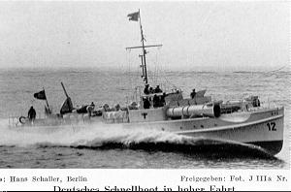  [Schnellboot (means "fast boat")  MTB means Motor Torpedo Boat] | canals of our village on their way to the Ijsselmeer. There are some beautiful slender boats among the mostly converted fishing boats. A German sailor told me those boats were Schnellbote (German for MTB's). An ex military Dutch sailor confirmed this for me. At the forward deck of the converted fishing boats they have put a small anti aircraft gun. The much larger MTB's have hard time taking the bend in the canal. The result is that sometimes the bridge stays open for hours.

Saturday August 31
The whole month of August German boats were passing Lemmer causing many problems with the bridges. On the occasion of our Queen's birthday, many persons were wearing some orange, our national color, on their clothing. One has to be careful, because if the wrong person sees this, it can cause problems.
To be continued.

How Orange is Linked to the Netherlands

The colors of the Dutch flag are red, white and blue -- there's no orange at all. So what's the Netherlands' relationship (make that borderline obsession) with the color orange?

The answer: Orange is the color of the Dutch Royal Family. The lineage of the current dynasty -- the House of Oranje-Nassau -- dates back to William van Oranje (William of Orange). But while the color orange has royal roots in the Netherlands, today it symbolizes a broader pride in the country and in being Dutch.

Perhaps the biggest display of orange national pride occurs on Koninginnedag ("Queen's Day"), the April 30 holiday commemorating the birthday the country's (former) Queen.

You'll be hard-pressed to find a Dutch person who's not sporting the color on this day.

The Dutch have been observing Queen's Day on April 30 since 1949, when the new Queen Juliana ascended the throne. Before then, the holiday fell on August 31, the birthday of Juliana's mother, former Queen Wilhelmina.

[Sorry. I forgot to note the web page this came from.]

WAR MEMORIES 5
1940
Monday September 23rd
German warships is continue to pass through Lemmer. The Germans have posted anti-aircraft guns at different places in, and around, Lemmer. They have also posted searchlights at the north and south side of the harbor and in our churchyard. One of the anti-aircraft guns is posted at the railway station. This is a four barreled gun, caliber 2 cm. (approximately 3/4 of an inch) Next the soccer-ground they have installed 2 or 3 very heavy anti aircraft guns, caliber 8.8 cm (3 1/2 inch)on concrete foundations. However, those guns cannot be used, because the area around Lemmer is too swampy. Every time they fire at airplanes, the guns shift, due to the swampy underground. At the end of the harbor-dam, they have posted an installation for listening for approaching airplanes. Almost every evening German airplanes, Heinkels and Junkers, fly over, from east to west. I believe they come from the airbase at Leeuwarden and are heading for England.

Tuesday October 15th.
This morning at the intersection of our street with another road, German trucks were parked with anti-aircraft guns and searchlights hooked behind them. After asking around, I found out that last night a British airplane, able to land on water, had landed on a lake nearby to pick up some people from the Dutch underground army. I wonder how the Germans could be here so quick. Has there been treason? Nobody could tell me exactly what happened. The Germans, of course, do not tell us anything.

Tuesday November 19th.  Father came home this morning with boxes of sweets. St. Nicolaas songs are printed on them. (St. Nicolaas is a children's celebration in most European countries at the 5th [or 6th] of December.)  The toffees in the boxes taste delicious. The text on one of the songs in Dutch reads in English:  See the moon shines through the trees  Children be quiet now as bees  The RAF came along last night  They are master in the air all right  Full expecting beats your heart  Who gets cake or is too smart?  Hitler started this terrible war  However, he will be spanked, therefore. | 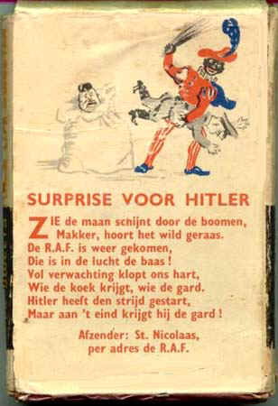
[Flyer picture from http://www.psywarrior.com/GiftsFromAbove.html]
New Years Eve December 31.
Our first year of war has gone by, and it looks as if the Germans cannot be defeated. Here in Lemmer we got a so-called Hafenuberwachungsstelle (German for harbor command station). The commander is a high ranked German navel officer. He is not tall, but when you she him walking in our streets, you know right away, this is a real kraut. The command post is next to the inner harbor quay. We also now have the Grune Polizei [German for green police or security police] stationed. In Lemmer, this rabble has taken for their terrible behavior our water-inspection building. Since the occupation on May 15th rationing now includes: Butter, Bread, Eggs, Cake, Coffee, Flower, Textile, Tea, Footwear, Fat, Meat, Meat-products and Soap. Every person older than 15 is now obliged to have an identity card on hand all the time.
To be continued

[Chronology added for your reading convenience]

1939
September 1st - Germany invades Poland.
September 3rd - Britain, France, Australia and New Zealand declare war on Germany.
September 10th - Canada declares war on Germany.
September 17th - Soviet Union invades eastern Poland.
September 27th - Surrender of Warsaw.
November 30th - Soviet Union invades Finland.

1940
March 12th - Finland signs peace treaty with Soviet Union.
April 9th - Germany begins occupation of Denmark and invades Norway.
May 10th - Germany invades Belgium, Holland and Luxembourg.
May 10th - British Prime Minister, Chamberlain, resigns, replaced by Churchill.
May 15th - Holland surrenders to Germany.
May 26th - Evacuation of British Expeditionary Force from Dunkirk.
May 27th - Belgium surrenders to Germany.
June 10th - Capitulation of Norway.
June 10th - Italy declares war on Britain and France.
June 14th - German army enters Paris.
June 18th - Soviets invade Baltic states.
June 22nd - France signs armistice with Germany.
June 30th - Germany begins occupation of Channel Islands.
July 10th - Start of Battle of Britain.
July 11th - Petain becomes head of French Vichy Government.
August 3rd - Italy begins occupation of British Somaliland.
September 13th - Italy invades Egypt.
September 27th - Germany, Italy and Japan sign Tripartite Pact.
October 7th - German army moves into Rumania.
October 28th - Italy invades Greece.
November 14th - Greek army repels Italians back into Albania.
November 22nd - Italian 9th Army defeated by Greeks.
December 11th - British capture Sidi Barrani, Egypt, from Italians.
December 17th - British recapture Sollum, Egypt.

WAR MEMORIES 6
1940
December 31
In the past few months, my friends and I have been watching the training of an anti-aircraft unit stationed on the dike of the North East Polder. One or two times a month a one engine German airplane, of the type Junkers, with a big sort of sack on a cable behind the plane, flies along the gun position, at which the crew then starts firing. I only saw the sack shot down twice.

1941 New Years day
The searchlight the Germans had posted last year just outside the North of our village has been shot away last night by one of our English friends' airplanes. People say a few Germans were killed. This is very well possible, because one of my school friends found a German helmet with a bullet hole in it, about 10 yards away from where the searchlight was posted. Today, when I went to the place where the searchlight was posted, it was abandoned. I heard the noise of passing planes last night, but I did not hear the shooting.

Thursday April 3rd
A son of our railway station chief, (a real German lover), who is, I suppose, about 20 to 24 years old becomes at this young age, head of the labor exchange in Heerenveen. Probably his purpose is to send as many people as possible to be laborers to German war factories. A typical job for a kraut friend.

Thursday April 10th
Last night I woke up because of many airplanes flying over. Of course, they were heading for Germany to give the krauts a cookie of their own dough (Dutch expression). When I looked out of my bedroom window I saw 4 huge flares in the air in a North Easterly direction.

Friday May 9th
Last night again there was a multitude of planes in the air. One plane came over at a low altitude. The Germans got this plane in their searchlights and started to shoot it. This plane dropped three red and two yellow small flares, and immediately the anti-aircraft guns stopped firing, and the searchlight went out.

Wednesday June 18th
All items made of copper, lead, nickel, or tin are supposed to be handed in. It does not matter how beautiful and valuable the items are, which are made of those materials. They have to be handed over. No exceptions are available. If you do not obey this order, you risk severe punishment. The Germans must have urgent need of these materials for their war. The best one can do is wrap items made of those materials in waterproof stuff and then bury them somewhere, or hide them on other good hiding places.

Wednesday June 22nd
Today the Germans have further enlarged the war. They invaded Russia. I must admit they have much grit and self-confidence. I sure hope Hitler, just like Napoleon in his time, smashes himself against the Russian bear.

WAR MEMORIES 7
1941
Thursday July 17th
Last night there were many planes in the air again. There was shooting high up in the sky. There was a fight going on between English and German planes, for sure. This morning, about 7 a.m., I went out to go fishing. When I walked through the second Parkstreet (we live in the first Parkstreet) I saw two men in an unfamiliar uniform sitting on one of the long doorsteps. They wore boots made of fur or something like it. They looked relaxed, and smoked a cigarette. They did not say anything but smiled at me. When I looked back, one of the two raised his hand. Who or what they were will be a riddle to me forever. I am sure they were no Germans and also not one of our villagers.

Monday July 21
Today I went fishing with my uncle Peter. Uncle Peter works at his anchovy preserver. Next to the preserver is a very large pond with plenty of fish. After I had enough fishing (I only caught a medium sized pike), I started to walk around the preserver. At the backside of the preserver, where usually nobody goes, I found some books, carefully packed in a piece of canvas and fastened with cord. I took the package with me to show it to my uncle. My uncle got rather upset and asked me never to talk to anybody about this package, not even at home. When I asked him, why not? He hesitatingly told me, and as he said in strict confidence, that those books were hidden there by Mr. de Rook some weeks ago before he was run in by the Nazis. Mr. de Rook is well-know villager, and was working here together with my uncle. I think it is all very mysterious, and certainly will not talk to anybody about what I found, and my uncle told me.

Thursday July 24th
Today a high ranked pilot of the RAF is buried on our churchyard. He is not the first RAF Pilot buried on our churchyard. Our neighbor de Jong told me the rank of this pilot was "Wing Commander." Neighbor de Jong works at our graveyard. According to the international rank book I bought, the same Dutch for this rank is: "Lieutenant colonel."

Tuesday August 19th
The allies have landed near Dieppe in France. Is this invasion we desire so badly, and talk about so much? The Germans tell us that the allies suffer heavy losses, but who believes the krauts?

The Dieppe Raid, was an Allied attack on the German-occupied port of Dieppe on the Northern coast of France on 8/19/1942. Over 6,000 infantrymen, predominantly Canadian, went ashore. The objective was to seize and hold a major port for a short period, both to prove it was possible and to gather intelligence from prisoners and captured materials while assessing the German responses. The raid was also intended to draw the Luftwaffe into a large, planned encounter. No major objectives of the raid were accomplished. Over half the men who made it ashore were killed, wounded, or captured. The catastrophe at Dieppe did greatly influence Allied plans for all later invasions.

Monday September 1st
Our summer holidays are over, and as of today, I go to the MULO school. (high school)
Tuesday October 12th
This afternoon there were at least four RAF planes attacking boats in our harbor. I believe they were Spitfires. I bought books (German, Russian, British and American) about plane recognition. [Why would he buy an American book when America was not yet in the war?] So far, I have only seen Luftwaffe and RAF planes. With all their anti-aircraft guns, and although the planes flew not much higher then house chimneys, they did not, as far as I could see, hit one of the planes.
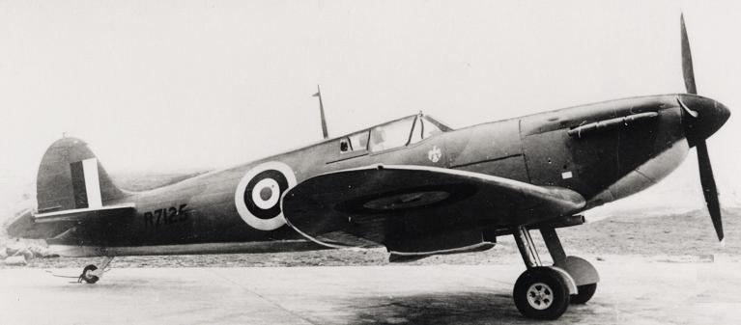
[Spitfire circa 1941]

Sunday November 1
Last night was a complete air war. About 7 p.m. the sky was full of planes and the shooting was tremendous. I heard some heavy explosions, I think east of us. Our house was shaking.
To be continued

Although night fighting had been undertaken in embryonic form way back in World War I, the German night fighter force, the Nachtjagd, had to virtually start from scratch when British
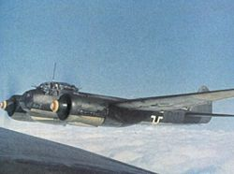  Junkers 88 | bombers began to attack targets in Germany in strength from 1940 as far as tactics were concerned. A chain of radar stations was established all across the Reich territory from Norway to the border with Switzerland known as the "Kammhuber Line", named for Generalleutnant Josef Kammhuber, and nearby night fighter wings, Nachtjagdgeschwader (NJG), were alerted to the presence of the enemy. These wings were equipped mostly with Messerschmitt Bf 110 and Junkers Ju 88 aircraft  From Wikipedia

WAR MEMORIES 8
1941
Sunday November 1
Today it became obvious that I was right about the direction of the explosions. Not far away, about 1 mile east of us, bombs were dropped because of an emergency. When an RAF bomber is attacked by a German night fighter, the bomber drops his load of bombs, in order to be more maneuverable. My friends and I went to the place where the bombs came down. Not too far away off the highway, we saw 5 large bomb-craters between the trees of a small grove. Quite a lot of the tees had been destroyed. There were also some holes in the area with a diameter of a yard or two in the more marshy soil without trees. It is likely that these holes were caused by unexploded bombs.

Monday December 8th
Yesterday the Japanese unexpectedly attacked an American naval base in the Hawaii islands. America declared war on Japan, and today America declared war on Germany too. Now we have a powerful ally, and therefore the Germans will lose this war for sure.

Wednesday December 31
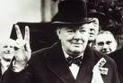 | It is New Years Eve and the second year of war is almost over. The V-sign (our victory sign - the index and the middle finger held up) was started this year, but was promptly taken over by the Germans with the slogan: V is for victory because Germany is winning the war on all fronts.

In February [It is not clear from the notes whether he is referring back to the previous February in 1941, or if these notes were written in February 1942 - see note below.] there was a big strike against the Germans in protest of the Nazis taking all the Jews to concentrations camps in Germany and Poland, where it must be terrible. The strike started in Amsterdam, and spread all over the country. The Nazis however beat the strike down in a terrible way. Potatoes and milk products were rationed this year. German officers are billeted at several places in Lemmer. Lemmer becomes more and more a German garrison. The German army is in front of Moscow, the Japanese have destroyed a great part of the American navy, so that all together it looks bleak and desperate.

[On February 25, 1941, the Communist Party of the Netherlands called for a general strike, the February strike, in response to the first Nazi razzia on Amsterdam's Jewish population. The strike was unique in the history of Nazi-occupied Europe, although it was quickly suppressed.]

1942
Friday March 13
Approximately 5 1/2 miles North of Lemmer the Germans have set up a camp with all kinds of strange apparatus. What it is, and how they use it, I do not know. Yesterday, when I was walking through the country to enjoy the springtime, I could see it clearly. One piece of equipment is at least 14 yards high, I think. [Radar site?]
Wednesday April 29th
Day by day, it gets worse for our Jewish fellow citizens. All Jews must wear a yellow star visible on their clothing. Police officer Kok, (who, if not a member of the National Socialist Party, is a strong supporter of the Germans), has arrested poor old Sarah and Joseph Blok. (The National Socialist Party, NSB for short, is the Dutch equivalent of the German National Socialist German Workers Party, NSDAP for short) Nobody knows where Kok took these old people.

Friday June 26th.
Last night I woke up because of so many planes flying over. It roared constantly. I could feel it in my chest. Naturally they were RAF bombers, but when I looked out of my bedroom window, I saw nothing.
To be continued.

[Chronology added for your reading convenience]

1941
January 5th - Australians capture Bardia, Libya.
January 22nd - British and Australians capture Torbruk.
February 6th - British and Australians capture Benghazi.
February 25th - British capture Mogadishu, Italian Somaliland.
March 1st - Bulgaria joins Axis.
March 25th - Yugoslavia signs Tripartite Pact.
March 27th - Yogoslav government overthrown - leaves Pact.
March 30th - German Afrika Korps begins offensive in N. Africa.
April 4th - Germans capture Benghazi.
April 6th - Germany invades Yugoslavia and Greece.
April 12th - Germans occupy Belgrade.
April 13th - Soviets and Japanese sign neutrality pact.
April 17th - Yugoslav army surrenders to Germans.
April 27th - Germans capture Athens.
April 28th - Germans take Sollum.
May 20th - German airborne invasion of Crete.
May 31st - British forces in Crete defeated.
June 8th - Allied forces invade Syria.
June 22nd - Operation Barbarossa - Germany invades Soviet Union.
June 22nd - Italy and Rumania declare war on Soviets.
June 23rd - Hungary and Slovakia declare war on Soviets.
June 26th - Finland declares war on Soviets.
June 28th - German Army captures Minsk.
September 5th - German army occupies Estonia.
September 15th - Siege of Leningrad starts.
September 19th - Kiev captured by Germans.
October 16th - Soviet Union moves government to Kuibyshev.
October 24th - Kharkov falls to Germans.
November 3rd - Germans capture Kursk.
November 22nd - Germans captue Rostov.
November 25th - Germans attack Moscow.
December 5th - Germans halt attack on Moscow.
December 7th - Japanese attack on Pearl Harbor.
December 7th - Japanese invade Siam and Malaya.
December 8th - Allies (except Soviets) declare war on Japan.
December 11th - Germany declares war on USA.
December 25th - Japanese capture Hong Kong.
WAR MEMORIES 9
1942
Saturday July 4th.
It was very busy in the air again last night. There was a lot of shooting. I could see the tracers going back and forth. I saw from my window, a plane on fire somewhere above Gaasterland, North of us. According to my bedroom alarm clock it was 1:43 A.M.

Tuesday August 4th
Keeping homing pigeons is no longer allowed as of today. Of course, the Germans are afraid that the pigeons will be used for transmitting messages from here to wherever the pigeon's homes are.

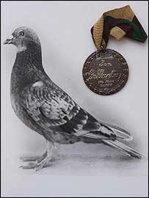
Commando
The PDSA Dickin medal was awarded to Commando the pigeon, which was bred in Haywards Heath in West Sussex.
Commando, of the National Pigeon Service, distinguished himself in three covert missions helping British agents against the Nazis. Parachuted into France, he flew crucial intelligence, strapped to his leg in a tiny canister, back to Britain in June, August and September 1942. The information revealed the location of German troops, industrial sites and injured British soldiers.
Commando, a red chequer cock bird, had only a one in eight chance of surviving, facing such hazards as German marksmen, exhaustion and even enemy trained hawks. His owner, Sid Moon, had served with the Army Pigeon Service, during the First World War. He immediately made his pigeons available again following the outbreak of war in 1939.
Commando was among 200,000 - 250,000 messenger pigeons volunteered for service by breeders during the conflict. He received his medal in 1945 for his "conspicuous bravery and devotion" before he was put out to stud. His name appears on a roll of honour alongside Royal Blue, the King's pigeon from the Royal Loft at Sandringham, Norfolk. The PDSA Dickin Medal, created in 1943, was named after Maria Dickin, who founded the People's Dispensary for Sick Animals. Only 32 were awarded in WW II. [From news.bbc.co.uk/1/hi/uk/4054421.stm]

Wednesday October 14th.
The boat "Holland," sailing between Lemmer and Amsterdam, was
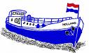 | attacked this morning by (English?) planes, 2 miles outside our harbor. The boat returned to Lemmer. There were 5 dead and 10 wounded. The captain was one of those killed. It is quite possible that the 4 Mustangs flying over Lemmer this morning that
were attacked by all the German anti-aircraft guns, were the ones that attacked the boat.

Wednesday October 21
Today planes attacked boats sailing between Lemmer and Amsterdam again. This time the "Friesland" and the "Groningen" were the targets. The "Friesland" returned with 3 killed and 3 wounded. Among the wounded is my Uncle Feite, who is chief engineer on the Friesland. On the "Groningen," among others, the navigating officer Stienstra was killed.

Tuesday November 24th.
The Germans are taking (stealing) all the church bells. Of course they use them as raw material for weapons etc. The bells in the tower of our church will be stolen too. I hope to not be a witness to this robbery. The Dutch Reformed Church is not too far away from our school, and when the Nazis are busy with their robbery during our school break, the chances are that we children will witness it.

Thursday December 17th
It is now 10 PM and I have been studying and writing since it became quiet again outside. After everything that happened tonight, indeed, you can say quiet. About 6 PM, there were several fights between German and RAF planes. When I looked outside for a moment, I saw all around in the dark sky tracers from the planes. I have begun to understand a lot about what happens above our heads. I saw a huge fire towards the North. It is probably a burning plane, recently shot down.

New Years Eve December 31
Mother, Aunt Anna, Aunt Alice, my two cousins, and my sister, went to church. Father, Uncle Peter, cousins George and Minnie, and me, were playing a nice game, when my school friend Paul de Rook came in our house. After he played the game a little while, he told us the real purpose of his visit. He had 3 big slices of magnesium and some gunpowder with him. Paul likes to experiment with war stuff, just like me and all my friends. He is one of the most active ones among us. Paul had a slice cut from a huge flare we had found attached to an unopened parachute.
To be continued.

WAR MEMORIES 10
1942
December 31
The flare had not burned in the air, and came down in a meadow in perfect condition. The slices had a diameter of 4 1/2", and were 1 3/4 inches thick. In the center of the three slices, he had made a small hole. Paul said that if we put some gunpowder in the hole, and we set fire to the gunpowder with a match, we would have a wonderful New Years Eve firework. He tried it already with a small piece in one of his father's fish smoking sheds. Paul's father is a fish smoker, just like my father used to be. We did not feel very comfortable with Paul's idea at first, but he talked me and my cousin George into coming along anyway.

In the School Street near the little parks between the first and second Park Street he lit them. Right after Paul had lit one of the slices, we started to panic. The burning magnesium gave such a glaring light, that all around it cast stark shadows. This was terrible, because the Germans did not want to see any beam of light, when it is dark outside. After sunset, when their police patrols walked through the dark streets, they sometimes fired through a windowpane at the smallest beam of light visible through the curtains. The cry "licht aus" (light off) is well-known. The three of us started to run as fast as we could. I ran directly to our home. Fortunately this was not so far.

I was scared to death the Germans would get me. I sat shivering at the dining room table. I peeped through the curtains and saw the glaring light above the houses on Park Street. Was this going to have a happy ending? I did not know where George and Paul were, but I expected every moment the German military police, or one of their Dutch accomplice police, at the front door, or at least on our street. However, nothing happened. The Germans were probably celebrating New Years Eve with a lot of Schnapps (alcohol). Father reprimanded me very seriously. He had not known, that what we were doing was so dangerous; otherwise I would not have been permitted to go outside. When mother and my sister came home just before curfew, (It was about 8.30 PM) they told us they had not seen or heard anything unusual. They had not seen any krauts out in the streets. This was a relief!

The third year of war is nearly gone by. The Germans are no longer invincible as they seemed at the end 1940 and 1941. In Russia and in North Africa the krauts are incurring heavy losses. When the invasion comes next year, every thing will be all right. In the past year, I did notice some nights of heavy war in the air. Those were the nights of 20 and 21 January, June 12, June 30, September 5 and September 14. In the cemetery in Lemmer there are 7 pilots buried. So far, I must say the Germans bury the enemy pilots with military honor. As soon as the coffin with the body of the pilot is in the grave, they fire a gun salvo. This year sweets and tobacco were rationed. Every thing that can be rationed must be rationed by now. What is not yet rationed is not available anymore. Our copper and silver money is no longer valid and supposed to be turned in. Who does this? Instead of good money, we now have paper and zinc money.

[Chronology added for your reading convenience]

1942
January 1 - Twenty-six nations signed the United Nations Declaration
January 2 - Japanese Campaign in the Philippines begins
January 11 - Japanese Occupation of the Dutch East Indies
January 13 - Soviets recapture Kiev.
February 1 - Establishment of Quisling Regime in Norway
February 8 - Japanese Offensive in Burma begins
February 15 - Singapore falls to Japanese.
March 8 - Japanese New Guinea Offensive
March 8 - Japanese enter Rangoon.
April 9 - Fall of Bataan
April 29 - Salzburg Conference
May 5 - British Occupation of Madagascar
May 6 - Fall of Corregidor Island
May 6 - British capture Madagascar.
May 6 - Surrender of all US forces on Phillipines.
May 7 - Battle of the Coral Sea
May 12-17 - Soviet Counter-Offensive in the Ukraine
May 28 - Germans defeat Soviets at Kharkov.
June 4-7 - Battle of Midway - 4 Japanese carriers sunk.
June 11 - Master Lend-Lease Agreement with the Soviet Union
June 12-21 - Japanese Aleutians Offensive
June 25 - Eisenhower Appointed Commander in Chief in Europe
July 3 - Sevastopol falls to Germans.
August 13 - Atomic Bomb Project begins
August 19 - Dieppe Raid
August 22 - Brazil declares war on Germany and Italy.
August 30 - German Annexation of Luxemburg
September 5 - Soviet Counter-Offensive in Southern Russia
October 1 - German Annexation of Northern Slovenia
October 23 - Battle of El Alamein begins.
November 8 - Operation Torch begins - Allies invade NW Africa.
November 11 - German Occupation of Vichy French
November 17 - Reorganization of Vichy French Government
November 27 - Scuttling of French Fleet in Toulon
December 1 - Darlan's Assumption of Control over French North Africa
December 24 - Assassination of Darlan

Thursday January 21st.
Father made a kind of hole under the floor of our living room. It is not very comfortable, but very difficult to discover. The entrance is hidden under a carpet, and you must know exactly where to lift the floorboards. Father says it is for the dangerous time to come, but I suppose father made it for Jan Nicolai, the fiancée of our cousin Baukje. Jan slept in our house already several times for an unknown reason. I am sure that Jan is with the Dutch underground army. Before the war he was in the army. Sooner or later I will find out. The problem is my parents never talk about anything around me. But when Jan comes to sleep, mother is always nervous.
To be continued
WAR MEMORIES 11
1943
Wednesday January 27th
It was about 11:30 this morning when our class was startled by a deafening roar of explosions. We were having a lesson in geography given by Mr. de Vries, and we all longed for the end of this boring lesson. The walls of our old school, at least 16 inches thick, shook like leaves on a tree. Every thing in our classroom shook, and the blackboard fell down. Mr. de Vries ordered us to go, as quick as possible, into the corridor and stay there flat on the floor. We had just taken this position in the corridor, when it became quiet and silent again. In my opinion it all lasted no longer then 5 minutes. Some of the girls with us in the corridor got very upset and cried for their mothers. After it was quiet for a while, Mr. de Vries went outside to check what had happened. In the mean time, we had to stay put in the corridor.

When Mr. de Vries came back, he told us that there were many planes in the air and that probably Lemmer had been bombed. The geography lesson was not continued, and Mr. de Vries ordered us to go immediately straight home. We did not have to come back today. A girl living in the same street where we live, Roelie Visser, and I ran home hand-in-hand as fast as we could. The sky was half covered with clouds, so we could not see any planes. However, we could hear the planes, and there was also shooting up in the air.

At home mother and my sister Alice were in a complete panic. Mother said that father was still at his work and that in the direction of father's work many bombs had fallen. Mother was terribly worried, but she did not dare go to see how father was, for fear that the planes would come back. Fortunately father came home a little later to tell us that he was unharmed and healthy. Some bombs had fallen about 16 yards away from him, but did not detonate in the soft marshy soil. They had covered the holes with packages of straw. Most of the bombs fell around our harbor and behind the railway track. It looked as if the meadows were ploughed. There were only a few fatalities. I do not know yet how many.

Friday February 5th.  This afternoon there were some planes flying over Lemmer. I recognized them as American Mustangs. The Germans fired violently at them, and they fired back. I do not know if the Mustangs killed any Germans, but I know for sure the krauts did not shoot down one of our friends. We are happy about that.  Sunday April 4th. | 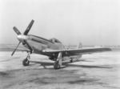  [P51 Mustang]
Today I heard that the krauts have arrested the father of my school friend, Frank Bootsma. Frank's Father is the captain of the "Friesland IV" a ferry boat that goes between Amsterdam and Lemmer. Perhaps Frank's father does work for the Dutch underground army.

Wednesday April 14th.
Last night a German aircraft crashed 4 miles north of Lemmer. It is a bit too far to go there. Since it is a German plane, I am sure we shall not be allowed to get near the plane, anyway.

Monday May 3rd.
There is a strike going on all over Friesland. I do not know where the strike started, but every where in Northern Holland workers stopped their daily labor. Even farmers are on strike and dump the milk not destined for civilians, in ditches. When farmers are on strike, then you can say this is a general strike, father told me. The reason for this general strike is the fact that the Nazis will put our demobilized military personal in POW camps again. Cousin Jake, who fought on the Grebbeberg Line, has gone into hiding. Due to the strike it is not permitted to be in public in groups of more than 2 persons. The krauts call that a riotous assembly.
To be continued.

[I found a note on the internet that said the Germans killed 200 people putting down this strike.]

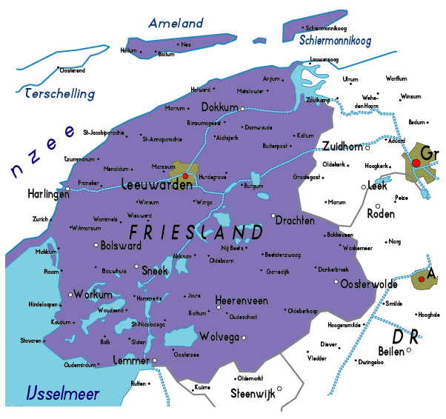

WAR MEMORIES 12
1943
Tuesday May 4th.
The Grune Polizei (German security police) killed an honest fisherman from Lemmer. This fisherman was waiting for a bridge to open with a few other people. For those Nazis more than two people together is considered a riotous assembly. Since the strike is not over yet, they shoot at people, when they are assembled, even when those people are just waiting for a bridge to open. This poor fisherman would not hurt anyone. The murderers came in a military vehicle with the canvas on both side rolled halfway up. They drove into Lemmer and started to shoot without any warning. We have heard that since yesterday in Friesland alone, at least 100 people have been killed. We all know now, that no greater rabble exist than SD and Grune Polizei.

Thursday May 13th.
All wireless radios are to be surrendered. Cable radios, of course, are not included. Cable radios are just Nazi propaganda anyway. The krauts are scared to death, that people in occupied Holland might listen to the real situation in this terrible war. I hope that families who possess a wireless, and I know several, will not all turn in their radio, and that they will tell us the truth about the real situation.

Friday May 14th.
In the middle of the night there were many airplanes in the sky. Between 11 PM and midnight the fighting above us was terrifying. There was fire everywhere. When I got out of bed, and looked through the window, I saw a huge fire not too far away from where we live. That had to be a plane that was shot down. Also, towards the North I saw a fiery glow, so there must also be a burning plane up there. We Dutch pray for the poor crews fighting for our freedom. Today I heard that not too far from the railway track an RAF plane was crashed. The whole crew died. My supposition from last night was correct. As soon as the Germans have left the crash spot, my friends and I will go there to have a look.

Sunday May 23rd.
Today we roamed through the fields on the other side of the railway track to find out where the plane had crashed 9 days ago. We did not dare to come too close to the crash spot, because there were still German patrols in the field. During our roaming in the field, we found a whole bunch of magazines. On the front page of the magazines were printed with large characters: "DE VLIEGENDE HOLLANDER" (The Flying Dutchman). These magazines must have been dropped out of an English or American plane. My friends and I kept a couple for ourselves and for our friends. The rest we spread over different places in Lemmer.

Saturday June 12th.
It has been almost a month ago that a plane crashed near the railway track. In the meantime the crew has been buried in our churchyard. The Germans have taken away everything they could use. They guard it no longer, so it was possible for us to have a look. There was beside a dike a big hole in the ground. It smelled very much of oil and gasoline. You could see that the Germans had tried to get something out of the hole. However, one could see that they had not succeeded. We think the heavy engine of the plane has sunk into the marshy underground of the place. Not far away from the hole that might have an engine, you could see that there had been a huge fire. Around that place we found all kinds of things.
To be continued.

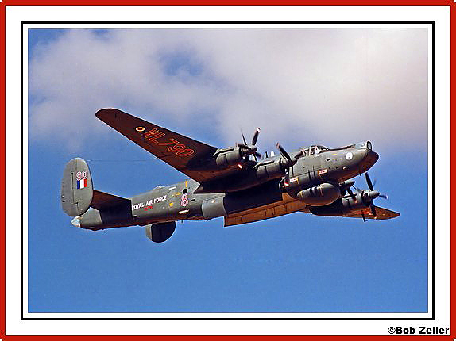

British RAF Lancaster Bomber

WAR MEMORIES 13
1943
Saturday June 12th
Among other things we found sweets, but we did not eat them, because there was oil on them. There were large pieces of hard cockpit plastic. We can make finger rings and other articles out of the plastic. We found little bags, filled with a powder, that if you made the powder wet, it became all the colors of the rainbow. If you got it on your clothes, you could not get the stuff off, even with water and soap. Our clothes became all the colors of a rainbow at the spot where the powder was on our clothes. There were also many little clocks with figures and characters we did not understand. We did not know what to do with them, so we left them there. We also found bullets attached to each other by links into a belt.

When we walked back through the high grass in the fields, we ran into a huge turret of Plexiglas. Two machine guns stuck out of the turret. We found the turret at least 500 yards away from the crash place. The turret sat deep in the soil and was unmovable. We did not succeed in pulling the turret out of the soil. The inside the glass of the turret was smeared with oil and mud, so we could not peak inside. We thought it possible that a body was still inside the turret. Because the Germans had not found the turret, and since it is forbidden to get near a crashed plane, we did not dare inform the local garrison commander. But we told one of our police officers that could be trusted, that we had seen something of a plane out in the field, and gave him, as best we could, a description of the location.

Monday July 26th
Roaming today through the fields we found bunches of aluminum foil or silver paper. We do not know what it is, or what it is used for. The slips were approximately 20 inches long and 3/4 inch wide. One side of the slips was black, and the other side was silvery. Whatever it is or whatever it is for, we took a whole bunch of the slips home, because we think that we can make nice Christmas decoration of the slips.

Chaff (radar countermeasure) from http://en.wikipedia.org/wiki/Window_%28codename%29

Chaff, originally called Window by the British, and Düppel by the World War II era German Luftwaffe, is a radar countermeasure in which aircraft or other targets spread a cloud of small, thin pieces of aluminium, metallised glass fibre or plastic, which either appears as a cluster of secondary targets on radar screens or swamps the screen with multiple returns.

The idea of using chaff was independently developed in the UK, Germany, and the United States. As far back as 1937, R. V. Jones had suggested that a piece of metal foil falling through the air might create radar echoes. In early 1942, a TRE researcher named Joan Curran had investigated the idea and come up with a scheme for dumping packets of aluminum strips from aircraft to generate a cloud of false echoes. The British referred to the idea as Window. Meanwhile in Germany, similar research had led to the development of Düppel. In the US, Fred Whipple developed a similar system (according to Harvard Gazette Archives) for the USAAF.

The systems were all essentially identical in concept, small aluminum strips cut to one-half of the target radar's wavelength. When dropped, the strips would give a strong echo, appearing as an aircraft on radar screens. Opposing defenses would find it almost impossible to pick out the "real" aircraft from the false echos. Other radar-confusing techniques included Mandrel, Piperack, and Jostle.

Then something odd happened: no one used it. Unaware of the opposing air force's knowledge of the chaff concept, planners felt that using it was even more dangerous than not: as soon as it was used the enemy could easily duplicate it and use it against them. In particular the British government's leading scientific adviser, Professor Lindemann, balefully pointed out that if the RAF used it against the Germans, the Luftwaffe would quickly copy it and could launch a new Blitz. This caused panic in Fighter Command and Anti-Aircraft Command, who managed to suppress the use of Window until July 1943.

Examination of the Würzburg radar equipment brought back to the UK during Operation Biting and subsequent reconnaissance revealed to the British that all German radars were operating in no more than three major frequency ranges, and thus were prone to jamming. "Bomber" Harris, Commander-in-Chief (C-in-C) of RAF Bomber Command, finally got approval to use Window as part of Operation Gomorrah, the raids against Hamburg.

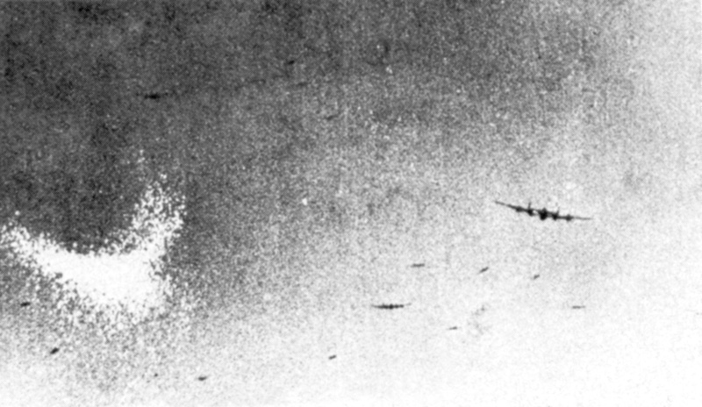
An RAF Lancaster dropping Window (the crescent-shaped white cloud on the left of the picture) from within the accompanying bomber stream.

The first to use it were 76 squadron. Twenty-four crews were briefed on how to drop the bundles of aluminized-paper strips (treated-paper was used to minimize the weight and maximize the time that the strips would remain in the air, prolonging the effect), one every minute through the flare chute, using a stopwatch to time them. The results were spectacular. The radar guided master searchlights wandered aimlessly across the sky. The AA guns fired randomly or not at all and the night fighters utterly failed to find the bomber stream. A vast area of Hamburg was devastated with the loss of only 12 bombers. Squadron Commanders quickly had special chutes fitted to their bombers to make the deployment even easier. Seeing this as a development that made it safer to go on ops, many crews got in as many trips as they could before the Germans found a countermeasure.

The use of Window rendered the ground-controlled 'Himmelbett' fighters of the Kammhuber Line redundant overnight but the Germans responded quickly, using non-radar equipped free-ranging 'Wild Boar' day fighters to attack visually. Some argue that, by using Window, the British forced the Germans to devise a more effective night fighter defense and had they left well alone then Allied bomber losses may have been ultimately smaller, and not worth the momentary advantage Window gave.

A lesser known fact is that Luftwaffe used this technology just six weeks after the above mentioned Hamburg raid. In a series of raids in 1943, and a larger series known as Operation Steinbock between February and May 1944, Düppel allowed German bombers to once again return to London. Although theoretically effective, the small number of bombers, notably in relation to the RAF's now-large night fighter force, doomed the effort from the start. The British fighters were able to go aloft in large numbers and often found the German bombers in spite of their Düppel.

Sunday August 8th.
My cousin Rita, and her husband Andy, were visiting us today. Since civilians can no longer have motor vehicles, Andy is doing all kinds of jobs with his horse and cart. He told us a sad, but on the other hand comical story. A couple of weeks ago, he had to bring the body of a drowned pilot to Lemmer. The body lay against the dike of the Suidersea. When Andy has to do such a sad job he gets assistance from two municipal workers. When the three had the body laid in the cart, they covered the body with a canvas tarpaulin. On their way to Lemmer along the dike, they overtook my Uncle Luke, who was on foot. Uncle Luke asked Andy, if he could get a lift to Lemmer. "Of course, Luke," Andy answered, "Sit down at the tarpaulin, there is no room for you in front." Uncle Luke did as he was told. He climbed up on the cart and sat down on the tarpaulin.

After a while Uncle Luke got curious about what was under the tarpaulin, and asked Andy what was under it. "It is so soft," he said. Andy answered, "Oh, Luke, nothing in particular. Look for your self." Uncle Luke did as he was told, and saw the body, that had been in the water for several weeks, and no longer looked so good. Uncle Luke, even though he frequently helps with searches for drowned people, clearly has a very weak heart. With a cry full horror he jumped from the moving cart, and went by foot the rest of the way toward Lemmer, calling Andy names for as long as he could be heard.

To be continued.

WAR MEMORIES 14
1943
Tuesday October 26th
Tonight, around 6 PM, it was real war here in Lemmer again. The air raid alarm was shrieking. The Germans were firing with all their anti-aircraft guns. High up in the sky planes were shooting etc. etc. We could hear and feel the heavy explosions of detonating bombs. It was all panic in our house. Two terrified lady neighbors came to our house for shelter with their daughters. Father had the late shift at his work, so besides me, there were only women in the room. Mother was nervously creeping on hands and knees through the house putting every thing that fell on the floor, thanks to the explosions, back in place again. You could say our home was a kind of madhouse.

Tuesday November 2nd.
Today I became 15 years old. As of now, I must have an identity card with me at all times.

Saturday November 13th.
Today is a dull cold day but with a new war experience. I had not heard planes, but just past noon I did hear an anti aircraft gun firing. By the sound I could tell, that it was on the south/east side of Lemmer. After a minute, or so, the gun stopped firing. An hour later I found out why the Germans had been firing, because my friend George came to me to ask, if I wanted to go with him to see a big plane that had made an emergency landing in a meadow south of Lemmer. Of course I went along.

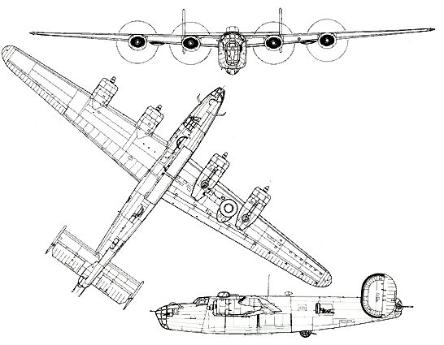
[Three views of B-24 Liberator]
It was quite a walk to the spot where the plane had made its emergency landing. As we came to the plane, we saw that it was an American Liberator B-24. The plane was badly damaged, but we heard from other people that the whole crew had come out the plane unharmed. The crew was captured by some older Germans, who have an air watch post not far away from the place where the plane landed. The old Germans around the plane let us look into the plane without bothering us. Inside, except for all the wiring, the plane is very empty. Later we were chased away by a fanatic kraut. The turrets with the guns made the most impression on George and me.

Wednesday November 17th.
Today I had to get my identity card from the municipal hall. It is ID Card nbr. L21-005992, I hope I never have to show it.

Friday November 26th.
As of 11:30 this morning the sky was crowded with American planes. Every where I could see the condensation trails of Flying Fortresses (B-17), Liberators (B-24), Lightnings's P-38 and Thunderbolts. There were no German planes around; anyway, I did not see them. As the last planes were still flying east, the first ones were already coming back, flying home. It had just been 1 PM, when I heard the noise of machine guns and other heavy guns. For an unknown reason we are again out of school. I stood with a few neighbors near the grove between the first and second park street looking in the direction of the shooting.

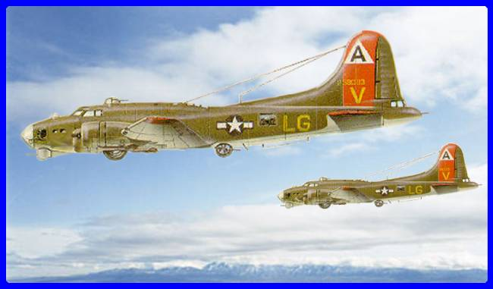  B-17 Flying Fortress | 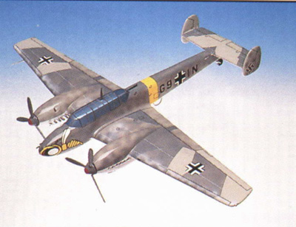  ME 110

Suddenly we saw a damaged Flying Fortress flying at low altitude to the Northwest. The crippled plane was attacked by at least three German planes (ME-110) Our American friend was alone with no fighters to protect him. The B-17 defended himself to the utmost. The fight lasted a long time. Suddenly I saw four parachutes hanging in the air, a part of the crew of the American plane. That they were Americans I concluded from the fact that those helpless young men, hanging on their parachute, were taking fire from two of the Nazi fighters. The big B-17 in the meantime whirled like a tree leaf to the earth. My friend William's mother, who was watching the tragedy too, could not control herself, and cried to the Nazis; "Dirty foul murderers!"
To be continued.
WAR MEMORIES 15
1943
Friday November 26th
Fortunately there were no Germans, or the wrong kind of Dutchmen, near by to hear what William's mother cried, otherwise she would be in big trouble. The people standing around supported her. I had not guessed the right spot, where the plane hit the ground, as I found out later, when I heard the exact crash place. Lately we have seen many balloons floating by. The Germans fire at the balloons with machine guns. I have also seen a German fighter plane shooting at the balloons. What the balloons might mean, I do not know.

Attack of the Killer Balloons!
[From http://www.vectorsite.net/avbloon_2.html]
On the night of 17:18 September 1940, a gale swept across Western Europe, tearing barrage balloons from their moorings. The balloons caused considerable havoc in Nazi-occupied Denmark and neutral Sweden, knocking out power and even toppling the broadcast tower of the Swedish international radio service. British Prime Minister Winston Churchill, who was fond of "thinking out of the box", suggested that if balloons could do this kind of damage without trying, they might do a lot more damage if deliberately sent over Germany to cause harm.
The Air Ministry examined the idea and rejected it, coming to the conclusion that the Germans would retaliate in kind, and that the British power grid was much more vulnerable to such attacks than the German power grid. There was also a perception that an offensive balloon campaign was a distraction from more important military programs. However, an Admiralty Board liked the idea, asserting that balloons would cause real confusion because they attacked so silently, and that the effort would not cost much in material or British lives.
The Admiralty envisioned the balloons carrying two or three incendiary munitions in the form of 2.7 kilogram (6 pound) "socks" filled with a phosphorus-based combustible material. Germany had large evergreen forests that could be ignited by such munitions, and dealing with the fire hazard would be a drain on German resources. Britain was less vulnerable to retaliation, since the UK's forests were small and mostly deciduous, losing their leaves in the winter and making them less prone to fires. Besides, at operating altitudes, the winds went from Britain to Germany about 55% of the time, but only blew 38% of the time in the reverse direction.
The Air Ministry countered with their original arguments, saying that the balloon program would be too expensive and ineffective, and added that the balloons would be a hazard to British aircraft. The Admiralty responded that the program was very cheap and that the resources needed, such as hydrogen gas, were in excess supply, and that procedures could be implemented to reduce the risk to planes and pilots. The clincher for the Admiralty's case was an analysis that showed the British power grid could generally withstand short circuits caused by German balloons trailing wires, while the German power grid would suffer badly from similar attacks by British balloons.
The program, codenamed OUTWARD, was approved in September 1941. The first OUTWARD launches were performed on 20 March 1942. Reports trickled back of balloon sightings and public warnings in Axis-occupied territory and operations ramped up, with a second launch site set up in July 1942. Arrangements were made with the RAF to ensure that balloons weren't launched when they could interfere with RAF bombing raids. Launches always had to be performed in daylight, with two hours advance notice given to the RAF.
The balloon campaign was scaled back in the spring of 1944 lest it interfere with the planned Normandy landings, and was finally halted completely on 4 September 1944, since by that time Allied forces were in the "line of fire" of the balloon attacks. Almost 100,000 balloons had been launched during OUTWARD, with a little more than half of the balloons carrying incendiaries and a little less than half trailing wires.
It is hard to say that OUTWARD had much to do with winning the war, but analysis showed that it was definitely cost-effective. It was implemented with less than 300 personnel, the bulk of them women, not men needed for frontline service, and cost about 220,000 pounds in all. The most spectacular success achieved by OUTWARD was on 12 July 1942, when a balloon shorted out power lines near Leipzig, causing a fire in a power station that then burned to the ground, with damages estimated at a million pounds. That was several times more than the British expended on OUTWARD from the first to the last.
The balloons were of course indiscriminate and also caused some damage in neutral Switzerland and Sweden, with a wayward balloon shorting out a Swedish rail lighting system on the night of 19:20 January 1944, leading to a train collision. There were diplomatic protests, but if the balloons were a nuisance to neutrals, they were likely a gross source of aggravation for the Germans -- who could only swear at the "damned devious Tommies" as balloons floated silently across the countryside, leaving a trail of damage behind them.

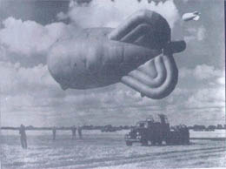
Barrage Balloon circa 1942

Thursday December 16th.
Tonight it was very crowded in the air, as usual. It was rather cold. Father and I were watching outside. We heard the noise of shooting up in the air. Suddenly, we saw tracers to the east and high up. Shortly after that a small fire ball appeared. The little ball grew rapidly bigger. It looked as if the fireball was coming in our direction, and we decided to go inside to have some shelter, but a terrible explosion stopped us before we reached the door. I had the door handle in my hand, when father and I were thrown by heavy air-pressure against the outside wall. When we looked back, we saw an enormous fireball, which seemed to come straight towards us. Suddenly this huge fireball fell down in pieces. Another war victim, for sure. We hoped, that it was a kraut, but we doubt that.

Friday December 17th.
Last night it was indeed an exploding plane. Too bad it was one of our British friends. The pieces lay spread over a large area not too far away from us. Also, the bodies of the poor pilots.

Tuesday December 28th.
We have Christmas holidays. My friends and I visited the place where the exploding plane with its crew came down not long ago. It was foggy, so nobody could see us. When we came to the crash site, we found all kinds of plane parts spread over the area. It was very awful, because we also found parts of human bodies. Those body parts belonged to the poor crew, of course. It is terrible. The Germans had most of the bodies gathered together and buried on our churchyard. Our churchyard looks like a military graveyard.

The fog started to clear, and suddenly we heard a gun shot. We looked in the direction of the sound, and saw two German soldiers with their rifles in hand. They saw us when the fog cleared, and to get our attention, they had fired a gun. We had the idea that the Germans had already taken away everything they could use, since we saw no guards. The soldiers ordered us to approach them. We obeyed their order, but since there was a wide ditch between them and us, we could not come too close.

The asked us: "Was macht euch dort?" (What are you doing there?)

We answered: "Wir sind neugierig" (We are curious)

They said: "Es ist viel zu gefarlich hier, schert euch weg" (It is too dangerous over-here, go away immediately)

We did as they said, and in a way, were glad to get away from this spot with human parts all around.

New Years Eve December 31st.
Again a year of the war has passed. It is a war that gets more and more furious day by day. Where we live the war is mostly in the air, crashing planes, and now and then, planes attacking ground targets. Within a radius of 10 miles around Lemmer at least 14 planes have crashed so far. But on the battle fields it must be awful. The bombing of Germany must have increased very much.
To be continued

WAR MEMORIES 16
1943
December 31st

This year the number of bombardments on Germany must have increased intensively. Day and night allied planes (bombers and fighters) fly over this area. Not withstanding the danger connected to the air war, the roaring sound of the plane engines is music to my ears. There is no pity what so ever for the civilian victims in Germany. In comparison with the situation on the fronts last year, a lot has changed. I keep track of the frontlines on a map of Europe. The Russians advance at a reasonable rate toward Germany. The krauts retreat, as they say, according to plan. Americans and Englishmen have landed in Italy, so there is already a kind of second front. Too bad it is still so far away from us. All together things are going in the right direction.

I still have to mention that in the past year, we found a new method to get an extra bread (German kuch) My cousin Andy has to take an order of food to the German Radar station 6 miles north of us with his horse and cart. [Is this the same site as mentioned in note for March, 1942?] The Germans have a kind of grocery store in the gymnastics classroom of our school. Sometimes we students can look inside, and then our mouths water from the site of all the delicious food in storage.

Well, back to my bread story. Andy gives us a hint about the day and time, he has to travel. He travels under supervision of an older German soldier. He is not a real bad German. When he feels home sick, he visits my cousin and his wife. According to my cousin Andy, this German hates the war very much, is worrying about his family, and is scared to death of being sent to the Eastern front. When we get the hint from Andy, father or I go to our vegetable garden along the road that Andy must go. When there is no one around Andy throws two loaves of bread from the cart. As quick as possible, we pick up the loaves. The old German does not see, or pretends not to see. In the evening we bring a loaf to Andy and his wife Rita.

Friday January 7th.
Lately, father works now and then at the pumping station of Lemmer. He had a precarious adventure this morning. He has to pass along the sea dike where several anti aircraft guns are positioned. The crews of the guns have a kind of shelter dug under the dike on the offshore side. Soldiers not on guard remain in the shelter most of the time. In the road they have made a small ditch running from the gun to the shelter. A wire in the ditch probably connects the gun position with a bell in the shelter. When (for them)enemy planes approach, the two soldiers on guard pull on the string and alert the soldiers not on guard. The alerted soldiers then come as fast as possible out of the shelter to the gun.

This morning father had a bag with fuel on a sled. Father does not know what exactly went wrong. He supposes that he pulled the alarm string. Due to the snow and ice the alarm string was no longer in the ditch, but on the road. The alerted Germans came running as fast as they could to their gun position. When they saw that it was not a real alarm, father was called names, in the usual German way. Father had to show his ID card, and the permit that he was allowed during curfew time to be on the road. When everything was found to be OK, he was allowed to go on. No word was said about the bag of fuel.

The soldiers manning the aircraft guns are mostly living in the Catholic elementary school. The officers are billeted with civilians. They use a part of an old farm on the street next to the street where we live, to maintain their guns and vehicles. At the entrance of the farm there is always a soldier on guard. Now and then, there is one on guard who comes from Austria. When he is on guard, and I pass him, he tries to have a chat with me. He told me that he had a son 18 years old, fighting on the eastern front from whom he has not heard for a long time. He lives with his wife and two daughters in small village called Leibnitz. I always feel sorry for him. After all, not every Austrian, is pro German. My parents will not allow me to invite him to come to our house for a cup of coffee.
To be continued.

[Chronology added for your reading convenience]

1943
January 14th - Casablanca Conference begins - Roosevelt demands "Unconditional Surrender".
January 28th - British 8th Army captures Tripoli.
January 31st - German surrender at Stalingrad.
February 8th - Soviets re-capture Kursk.
February 14th - Soviets re-capture Rostov.
February 16th - Soviets re-capture Kharkov.
March 15th - German Army re-takes Kharkov.
May 12th - Surrender of Axis forces in North Africa.
July 10th - Operation Husky - Allied landings in Sicily.
July 25th - Mussolini's Italian Fascist government overthrown.
July 26th - Marshal Badoglio declares martial law in Italy.
August 23rd - Soviets re-capture Kharkov.
September 3rd - Italy signs armistice.
September 10th - Germans occupy Rome.
September 23rd - Mussolini declares Fascist government in Northern Italy.
September 25th - Soviets re-take Smolensk.
October 13th - Official Italian Government declares war on Germany.
November 6th - Soviets re-capture Kiev.

WAR MEMORIES 17
1944
Tuesday January 25th

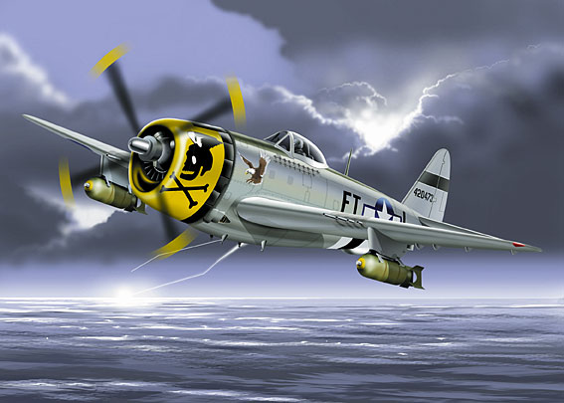TToday dozens of Thunderbolts p47, were flying at low altitude over and around Lemmer. They were probably searching for good targets, but I did not see them attack anything. The German anti aircraft guns did not fire on them either. Of course, they were afraid of so many planes. Maybe the Germans were also afraid of showing their position. It was so comforting for us Dutch, that our American friends were the masters over our village for at least 30 minutes. It is also possible, that the planes were searching for the firing sight of the new German weapon the V-1, a kind of unmanned plane. I saw one for the first time flying over Lemmer. The V-1 made a strange flopping noise. I think that this one had lost his target direction because it flew from Southeast to Northwest.

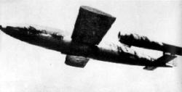
[V1 Flying Bomb]

Wednesday March 15th
Today many Thunderbolts were flying above the Suidersea. They were clearly searching for German boats sailing on the Suidersea. Now and then we could see them diving, and then heard machine guns firing. The targets were too far away from us to see what they were. We climbed in the unmanned lighthouse tower to have a better view, but the Northeast Polder dike was in the way, so we still could not see anything.

When I am talking about "we," I always mean my friends; George, William, Jan and myself. When we climbed down again an unpleasant surprise waited for us. At the bottom of the light house stood the Hafenuberwachungs commandant waiting for us. We had to go with him into a German FLAK-boat (a FLAK-boat is a boat with heavy anti aircraft guns of 8.8 centimeter or 3 1/2 ") The Germans use those boats for escorting their convoys.

Down in the boat this man started to call us names in the usual German way, and he started to beat us too. He was upset that allied planes could fly around, and he was not able to do anything about it. He tried to get rid of his frustration on us. A German naval officer started to talk to him and gave us a hint to disappear. I think that this officer was the commander of the FLAK-boat and therefore the boss on the boat. We obeyed immediately the hint of the FLAK-boat Commandant and felt safe again only when the dike was far behind us.

Tuesday June 6th.
Today is the happiest day we have had in a long time.

Weibe vander Bijl came to us with wonderful news, that early this morning the invasion started. The vander Bijls must still have a wireless radio. Weibe vander Bijl told us, that Americans, British, and Canadians had landed in Normandy, France. He had no more details yet. We hope and pray, that this time, the invasion will be more successful than the one near Dieppe, where the allies were thrown back with heavy losses.

Thursday June 8th.
They dig trenches along all the roads on both sides about 12 yards apart. People say, that the trenches are made to give the Germans cover, when the invading troops come, and to for cover when planes attack them. The trenches have just enough room for one soldier. We Dutch say the Germans are digging their own future graves. At a distance of approximately 100 yards much bigger hiding places are made. Those bigger places are cov [Original apparently stops mid word]

WAR MEMORIES 18
1944
Saturday August 5th
At three o'clock this afternoon the train from Heerenveen to Lemmer got attacked by American Mustangs P-51 only a few mile away from Lemmer … [apparently a line or two is missing from the original at this point] … Mustangs. One person was killed and two persons wounded. The person that was killed, is a German friend, Mr. Kranen, so nobody will feel sorry for him. The wounded ones are Mr. Groes, and our neighbor, Mr. Prins. Thank God that Mr. Groes and Mr. Prins only got wounded. When Mr. Prins came home after being treated for his wound, he said that the planes first flew around the train so there was time enough to abandon the train. However Mr. Kranen, who was in charge on the train, ordered it not to stop, but to ride on. Therefore we concluded that in a way, Kranen committed suicide.

Tuesday August 29th.
We were swimming in the Suidersea when suddenly 4 Spitfires dove towards a convoy of cargo boats under protection of two German FLAK boats sailing out of the Lemmer harbor. The fighters fired fiercely and the German FLAK boats fired back like the devil. Unfortunately one of the Spitfires was hit and crashed behind the Polder dike. A huge cloud of black smoke went up. Nobody jumped out of the plane, so the poor pilot must have been dead instantly. We hope the pilot made a couple of victims among the krauts, before he was killed. It is quite possible he did, because the FLAK boats returned to our harbor. The other three planes flew around for a while at high altitude, and then disappeared in Westerly direction. It all happened so quick, that we were too dumb founded to get out of the water, and seek cover behind the dike.

Monday September 4th.
As of today, we have to stay inside the house from 8 PM till 6 AM. It is still possible for us to go to our family next door through the garden on the backside of the houses. It also not too risky to cross the street quickly to go to my mother's sister, Aunt Anna. I am always talking about Aunt Anna and never about her husband Harry. The reason is, that Uncle Harry, who is an American, was called back to the United States by the American embassy, shortly before the Germans invaded Holland. Uncle Harry planned to get a house in New Jersey, and then his wife and children would follow. Too bad that following him was no longer possible due to the war. Since December 8, 1941, the Gestapo (German Secret State Police) have raided Aunt Anna's house twice. The house was searched completely from attic to basement by those blood dogs. What they were looking for they did not say, but the raids were very frightening for Aunt Anna and my cousins.

Wednesday September 6th.
I do not know exactly what is going on, but it seems that Dutch friendly to the Germans that were living in western Holland are on the run towards Germany. Perhaps this is because our allied friends are advancing so rapidly through Belgium towards the Netherlands. The boat from Amsterdam to Lemmer was loaded with German friendly Dutch travelers. A train waited at the station with 10 carriages and the locomotive under steam. The train departed towards the east (the only direction a train departing Lemmer can go). We were not allowed to come too close, and were chased away by a Dutch SS'er, who pointed his gun at us.

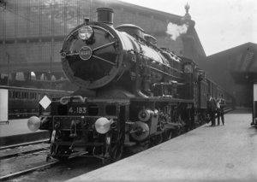
[European Locomotive circa 1930-40's]

Friday September 8th.
It looks like the Germans expect the allies (our friends and liberators) to be here in the not too distant future. They build pillboxes in the parks between the park-streets. They make those pillboxes of big concrete sewer pipes. They cover them with concrete poles and then on top put dirt and sods of grass. They have, among others, rounded up my friend George to dig those holes. I am not yet 16 years old, and still too young to be forced to labor for them.
To be continued.

WAR MEMORIES 19
1944
Friday September 8th.
We all hope those pillboxes are never used. If they are those near them will have big problems, when our Liberators arrive. The Germans are also building pillboxes on the South side of Lemmer. They have buried mines around Lemmer too. At several places they have put signs with the words "ACHTUN MINEN" (Attention mines). On the signs you also see a skull. We will wait and see. I now know, who the underground (The Dutch secret army) friend is. He has hidden himself, and slept twice under our living room.

Sunday September 17th.
Wiebe vander Bijl came and told us that the allies had dropped paratroopers near Arnhem and south of Arnhem. English paratroops have landed at Oosterbeek, West of Arnhem, and American paratroops have landed at Groesbeek, south of Nijmegen, and at Veghel north of Eindhoven. Thousands paratroopers came by parachute and big gliders. My cousin Jan and his fiancée Greta just went back to their home in that area last Wednesday. They were visiting with us for a few days. They went back just in time, and may be liberated by now. Our liberation is becoming more real to us. Three months ago the landing in Normandy, France and Belgium are liberated, and now our friends are already in Arnhem, only 75 miles away from us. It will not be long anymore and we can take revenge on the Germans and their Dutch friends.

Sunday September 24th.
We all are very sad, because it is not going well near Arnhem and Oosterbeek. It looks as if the Germans will win this battle. A large part of Southern Holland is liberated now, but the Rhine River seems to be a too difficult a task for our liberators.

Monday September 25th. Tonight at about 17:45 PM we had such a terrible fright. From the Northwest came a deafening sound. It seemed as if the world would perish. Nobody could tell what was going on. I thought that the radar station North of us was bombed, although I did not hear planes at the time. Tomorrow I shall try to find out what happened.  Wednesday September 27th.  I know what happened last Monday night. It is a new German weapon called the V-2. The Germans fire the V-2's from a forest 6 to 7 miles away from us. The V-2 is a rocket. | 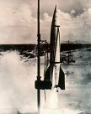
Saturday October 7th
Father, Uncle Peter and I went out today to collect wheat, rye and potatoes. We trade salt that farmers need very much at this time of year. There is still enough salt left over from before the war in the fish factory. The salt was originaly meant for salting ansjofish. Ansjofish is no longer supplied so there is no use for the salt anymore. But in the stores there is no salt. We stopped at a farmer's, who could use the salt very much. The trade was completed in no time. As an extra, we even got a piece of meat. In the farmers house it smelled delightful from baked potatoes and bacon. When father said, "What is that delightful smell?" the farmer told us that they had just finished lunch. Father told him that so far today we had only bread and butter to eat. I believe the farmer became sorry for us, because he offered us their leftovers. Since the delightful smell had made us hungry, we accepted his offer, of course. We were invited to sit down at the table, and we he gave us a well prepared pork chop.
To be continued.

Notes on Salt
(from various sites on the internet)

Salt is so simple and plentiful that we almost take it for granted.
In chemical terms, salt is the combination of a sodium ion with a chloride ion, making it one of the most basic molecules on earth. It's also one of the most plentiful: it has been estimated that salt deposits under the state of Kansas alone could supply the entire world's salt needs for the next 250,000 years.
But salt is also an essential element. Life itself would be impossible without it, since the human body requires salt in order to function properly. The concentration of sodium ions in the blood is directly related to the regulation of safe body fluid levels.
The effects of salt deficiency are highlighted in times of war, when human bodies and national economies are strained to their limits. Thousands of Napoleon's troops died during the French retreat from Moscow due to inadequate wound healing and lowered resistance to disease - the results of salt deficiency.
Salt has a long and influential role in world history. From the dawn of civilization, salt has been a key factor in economic, religious, social and political development. In every part of the world, salt has been the subject of superstition, folklore, and warfare, it has even been used as currency.
As a precious and portable commodity, salt has long been a cornerstone of economies throughout history. In fact, researcher M.R. Bloch conjectured that civilization began along the edges of the desert because of the natural surface deposits of salt found there. Bloch also believed that the first war - likely fought near the ancient city of Essalt on the Jordan River - could have been fought over the city's precious salt supplies.

WAR MEMORIES 20
1944
Saturday October 7th.
On our way back home, we loaded some wood we found washed against the roadside, into our handcart. This wood was possibly meant for making wooden shoes, but we could easily use it for our fireplace. Halfway back home we were stopped by a patrol of the Grune Polizei (German security police). The rabble first asked for my ID card. They looked at me and asked: "Is that your hair?" I told them in my best school German, "I put soap in my hair before I had a picture made of me." Then they asked, "Why did you do that?" I said, "As you can see my hair is wavy, and I did not want to look like a girl in the picture." They smiled and asked what we had in the handcart. I answered, "Well, Sir, Soon it will be wintertime so we have been searching for wood, and from various farmers we got some wheat and rye." They were satisfied with my answers and did not even ask for the ID cards of father and Uncle Peter. They allowed us to continue our walk towards Lemmer.

Wednesday October 11th.
Since September 25th, about 2 weeks ago, I have heard at least 25 V-2 rockets fired. When a V-2 is fired by daylight, you can easily see the trail of steam or smoke, similar to the white contrail of a plane. With a V-2 rocket the trail is going straight up in the air. When RAF or American fighter planes are around, when a V-2 is fired, those planes dive like birds of prey to the place, where the rocket was fired. As far as I know the planes have had no success so far. Tonight when I came back from buying milk at a farmer's a V-2 rocket was fired. It was visible against the clear sky in the West. I could follow the trail easily. The rocket went through the cloud bank in that direction. When that monster was far above the cloud bank it suddenly changed direction back toward earth. I suppose something went wrong. Not much later I heard a dull explosion. I do not know where the rocket came down, but I hope it was not near Dutch people or their property.

Saturday October 28th.
Father, two uncles, and I went out by foot to a place where farmers grow tobacco, about 10 miles away from our village. Money is not important to farmers, but we still have salt, which is in great shortage. We use salt as a trading article. I had to come along again, in case we were stopped by the Nazis, to talk to them. The tobacco was reasonably good for my uncles. My uncles are fisherman, and would rather have some chewing tobacco behind their teeth than smoke cigarettes or a cigar.

On our way back home along a road with water on both sides as far as one could see, we overtook three young girls about my age. After we had spoken to them, they told us that they had come from Amsterdam to Friesland to collect some food, because in Amsterdam people died of starvation. They came in a boat by night because sailing in the daytime is too dangerous. Allied fighter planes attack boats sailing in the daytime, because those boats could belong to the enemy. The girls had been lucky and gathered a good amount of food: potatoes, wheat, carrots and meat. They got all the food for reasonable prices. Father offered to carry their heavy bags.

One of the girls, named Geri, started to talk to me. The other girls talked with father and my uncles. Geri told me that the first night after their arrival in Friesland, they slept with a family in Follega, the second night they slept in Balk with the family of a police (good one) officer. They sure hoped that tonight they could go back to Amsterdam. Geri told me that at first, they had been afraid when four such tall men walked behind them on that road surrounded by water. Therefore they had hesitated near a farmer to let us pass. When we arrived in Lemmer we got the news the girls could not sail home. The boat was not taking civilian passengers. The Nazis had taken the boat for their own business that night. The girls had to stay in Lemmer.
To be continued.

Notes from the internet: The Starvation Winter
The defeat of the British and Polish airborne forces at the Battle of Arnhem in 1944, isolated the northern part of the Netherlands. With the German armies under pressure on all fronts, supplies dried up. The starvation winter of 1944-45 claimed countless lives in Amsterdam. (20 to 25 thousand) To get wood to fuel their fires, people pulled down thousands of empty houses - often those of deported Jewish families. Germany surrendered on 5 May 1945, and two days later Canadian troops liberated Amsterdam.

From the childhood memories of Hans A. Muller
http://www.bbc.co.uk/ww2peopleswar/stories/74/a2006074.shtml

Our family
I was a skinny boy then, 11 years old, living in Amsterdam with my parents, my 14-year-old sister Anneke and baby brother Bob. The southern parts of the Netherlands were already liberated, but after the "Market Garden" disaster, we lost all hope for a rapid end of the war.

After September 1944, the National Railway system went on strike and food became increasingly scarce, because the Germans had inundated most of the agricultural western parts of Holland. Food rations consisted of sugar beets, tulip bulbs, industrial-grade potatoes and bread made of ingredients that you would hesitate to use as fodder for cattle. I myself suffered for some time of hunger oedema, but our father succeeded in finding supplementary food by trading a few hoarded cigars, some bars of soap, tea (by the teaspoon) and coffee for flour, cheese, milk and oats. Later, soup kitchens opened but the quality of that soup became more and more a danger for what remained of your health. No electricity, no gas, no coal, only some soft peat for cooking and heating. Notwithstanding the strict curfew the beautiful trees along the canals disappeared rapidly during the night, as did the impregnated wooden block pavement between the tram rails. But that was extremely dangerous, you could be shot on sight by the military police or their armed Dutch collaborators. The houses left by the Jewish community were also stripped of anything that could burn, and my grandfather, a retired cabinet maker, used most of his wooden tools and precious wood reserve in the kitchen stove to cook sugar beets and rye porridge (try to grind rye in a coffee mill....). Miraculously, water supply was maintained although pressure was low.

Swedish white bread
In the beginning of 1945, some relief came from Sweden; under the Red Cross flag on coasters and inland barges they sent flour and margarine to Amsterdam and the other cities and distribution in Amsterdam started on 27 February 1945. But this gave only temporary relief; in Amsterdam alone - a city of then 500,000 inhabitants - an estimated 20 to 25,000 people died of starvation.

Operation “Manna”
Then, starting on the 27th of April, hundreds of huge Lancaster bombers approached at treetop level from the west, and dropped food, a few days later followed by American B-17 “Flying Fortresses”. There was K-rations, flour, Welfare biscuits, powdered eggs, Irish stew; the crews dropped small parachutes with chewing gum and candy for the kids. It was something you will never forget, as long as those who were there will live. You KNEW the war was over at last, although there were still armed German soldiers in the streets. After all these years, I still get tears in my eyes when I see one of those very few remaining Lancasters and B-17's in a museum, or during an air show. And my wife does not understand, because she was born in another country, and too young to see the ugly face of a war.

As a matter of fact, most of that dropped food reached the population only weeks later since there was hardly any means of transportation left (nearly all horses had either been requisitioned by the Germans, or eaten....). But the psychological effect was tremendous, it kept us alive.

May 4th
Evening, curfew. Then, a window opened and a neighbour who had listened to “Radio Oranje” shouted: “They have surrendered, it's over!” And then the streets filled with people, the national colours red-white-blue and with an orange pennant appeared everywhere. An old man died, his emotions had overtaxed his undernourished body, but he died with a smile on his face, it was over.

And my father got the very, very last item from his secret store: a small tin with cocktail sausages. I still see the tin before my eyes, the small key attached to the lid, the cocktail sticks in a paper wrapping. There were two, for each of us.

Liberation
May 6th: a reconnaissance group of Canadians enters Amsterdam, and is welcomed by a jubilant crowd on the central square, the “Dam”. Unfortunately, they had to pull back, and shortly after that, SS troops opened fire on the crowd, killing tens of people. But a few days later, after the formal surrender at Wageningen the Allied troops (mostly Canadians) arrived; they rode in jeeps, those marvellous little cars, Bren carriers, half tracks, tanks and motorcycles. Unforgettable, those soldiers, strong, suntanned men (in fact, boys, some could not have been older than 18 of 19), handing out chocolate bars and sweets, their vehicles hardly visible under the load of happy boys and girls. One image remained dormant for many years in my memory: a white polar bear painted on one of the vehicles....

Field kitchen
May 9th or 10th, I do not exactly remember, the food of the soup kitchen was completely uneatable; soup of rotting potato peels, with chunks of sugar beets and unidentified other ingredients. I had waited already for three hours in line, but they told us to wait some more, because help was coming. That help was a Canadian field kitchen; they started to empty huge tins of condensed milk and Welfare biscuits to make a VERY nourishing meal; also chocolate bars with raisins for everybody. (Some people, not used to this kind of food, literally ate themselves to death).

A couple of years ago, I had a talk with a young female Canadian soldier, who also participated in the famous International 4-Days Marches at Nijmegen (every year between 36 and 40.000 participants from every corner of the world). She had already observed that especially the Canadians enjoyed much popularity, and that even young people talked about the Liberation of May 1945. Then I told her this field kitchen story; she looked at me with some amazement and said: “I realize now that in May '45, my parents were not yet born!”. And I could assure her that the Dutch have elephants memories...

Polar Bear
Decades later, I read some books and saw some pictures of those days that we lived in a dream. And all at once, there was that little Polar Bear again, on a despatch rider motorcycle. Being retired, and having renewed my interest in motorcycling, I was fortunate to buy such a motorcycle, a 1942 BSA WDM20. However, she was in a very sorry state and it took me nearly seven years to source the parts needed and to restore her completely. And of course, the petrol tank bears the “Polar Bear” emblem. Since then, I have ridden her (together with my daughter on another, but later classic British motorcycle) with much pleasure, a slow, strong, dependable bike with character. I dream to go to England one day on a pilgrimage, a late "thank you" for the Brits, Scots, Welsh, Canadians and Americans that liberated us. We have not forgotten!

Hans Muller who in spite of the hunger oedema, became a 6'4" father of two daughters, and two grandchildren. To whom I will leave that WDM20....

WAR MEMORIES 21
1944
Saturday October 28th.
We only have room for one extra person to sleep in our house, so we had a minor problem. It was against curfew, but mother found the solution. One girl could stay with us, and the other two could stay next door with our family. Geri remained in our house.

Sunday October 29th.
The next night the Germans had taken the boat again for their own use, so the girls had to stay one more night in Lemmer. Geri told us a lot about life in Amsterdam. What we heard was awful. Later that day, Geri told us that today was her birthday. She is 17 years old today. That was the reason why she wanted so badly to be home with her parents and younger brother. My mother felt sorry for Geri. Mother is inventive. She arranged a kind of birthday party with chocolate milk, made of our last cocoa, and baked a cake of sugar, self-churned butter and ground flour.

I have not heard V-2's since Friday, October 20th. From the first one on September 25th until now, I counted 45 of the V-2 rockets.

Friday November 10th.
Every other day I get milk from farmer Hoekstra. Hoekstra lives with his sister and brother close to a lake about one mile away from the road. The fields around their farm in flooded. The water stays approximately 10 inches high. To get to their farm I must bike through water. I can not see the small path to the farm, and therefore use the barn door as my guide. I have to be careful, because on one side of the path to the farm is a small railway track used by Hoekstra to bring the milk cans to the road. On my way back from the farm to the road the fence gate is my guide.

So far it has been OK, but today I made a big mistake. The front wheel of my bike hit the railway track, and I fell full length into the water. I was soaking wet. Fortunately this happened on my way to the farm, so I did not have milk in my bottles. Near the stove in the farmhouse I dried a bit. An hour later I went back home, more carefully.

Saturday November 11th.
At about noon at least 24 Typhoons flew over Lemmer at low altitude from south to north. The German anti-aircraft guns did their utmost, but fortunately did not hit one plane. At the local slipway, there was a German boat in repair. The crew of this boat began firing too. But they stopped right away, because the boat started to shake. Since a boat on a slipway is held in place by wedges made of wood, it was possible the boat could capsize. In our back yard, I had a good view of this boat. Not much later I heard several explosions not too far away to the North of us. I believe the Typhoons bombed something.

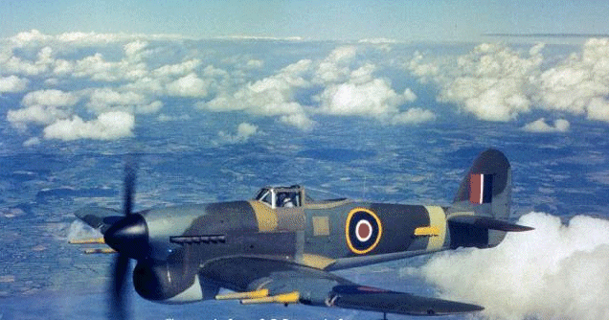
Typhoon

Sunday November 12th.
Today I heard that one of the Typhoons was hit by the anti-aircraft and had crash landed 1 1/2 miles east of us. The pilot escaped with the help of our secret army. I also now know that the Typhoons bombed locks near Terhorne. The krauts can no longer use those locks. The bombing was done at the request of the secret army.

Friday November 17th.
This morning around 10 AM my friends Jan and I were in the center of our village looking at 10 SS soldiers who had posted 2 heavy machine guns near the bridge. Why they did so, we do not know, and you can not ask those nazis their reasons. After a while the son of our station master (a well known German friend NSBer) came to us to have a look too. To be continued

Nationaal Socialistische Beweging (From Wikipedia) The NSB (National Socialist Movement), during most of the war the only allowed Dutch political party, actively collaborated with the German occupants. In 1941, when Germany still seemed certain to win the war, about 3 percent of the adult male population belonged to the NSB. After War broke out the NSB sympathized with the Germans, but nevertheless advocated strict neutrality for the Netherlands. In May 1940, after the German invasion, 10,000 NSB members and sympathizers were put in custody by the Dutch government. Soon after the Dutch defeat on 14 May 1940, they were set free by German troops. In June 1940, NSB leader Anton Mussert gave a speech in Lunteren in which he called for the Dutch to embrace the Germans and renounce the Dutch Monarchy, which had fled to London. The NSB openly collaborated with the occupation forces. Its membership grew to about 100,000. The NSB played an important role in lower government and civil service; every new mayor appointed by the German occupation government was a member of the NSB. After the German signing of surrender on May 6, 1945, the NSB was outlawed. Mussert was arrested the following day. Many of the members of the NSB were arrested, but few were convicted; those who were included Mussert, who was executed on May 7, 1946. There were no attempts to continue the organization illegally.
WAR MEMORIES 22
1944
Friday November 17th
The guy asked us if we knew what was going on. We did not know, but my friend Jan told young Mister Grolleman a good fantasy story to scare him. Jan said, "Do you really not know what is going on?" Between Kuiner and Vollenhove (18 miles from here) thousands of British and American paratroopers have landed and are now advancing towards Lemmer. We are waiting here for them. Mr Grolleman was quite shocked and ran to his parents. He did not come back.

Wednesday November 22
All day long we had allied fighters around Lemmer attacking everything that was moving. A tugboat that ran aground was attacked several times. The boat is all logs. A boat on Brekken Lake was also attacked. There were 5 victims, all German friends, so we do not feel much pity.

Saturday November 25th
This afternoon we went with a small rowing boat along the Northeast Polder Dike to the place, where on last August 29th, a spitfire crashed. When we left home, it was beautiful weather. We searched for driftwood along the dike. At the crash spot, we saw that there must have been a huge fire. We did not find any interesting things. We only took 20 machine gun bullets with us. We hid the bullets under the wood we had gathered, and rowed back towards Lemmer.

After rowing a while near the dike, all of a sudden, out of nowhere, a dense fog covered us like a blanket. Fog at sea means that you lose all feelings for direction, because there is nothing on which you can guide yourself.

We knew that if we rowed in the wrong direction, we would be lost on the Suidersea with all the consequences. We also knew that the wind had been blowing from the east so we decided to row in the direction of the small waves. If this was right, we would eventually reach the shore. After we had been rowing for about half an hour, it became a bit dark, and we heard the noise of a heavy ship engine. Hoping there was a boat not too far away, we started to yell; "Ahoy, ahoy!" Our yelling was noticed, because the noise of the engine slowed down. Suddenly we saw a huge German boat. The engine of the boat almost stopped and we rowed toward it.

Sailors threw a rope to us, and after our row boat was fastened to their boat, we were, one after another, lifted to their boat. The sailors asked us: "Was macht ihr hier aufs Mehr" (What are you doing here at sea?). We told them we had gathered wood along the dike for our parents at home, and that as we were rowing back to Lemmer, we suddenly were caught in the fog. They said: "Ihr Jungs haben cluck gehabt, dasz wir gerade vorbei kamen" (You boys were lucky that we came along.) Then one of the officers asked us if we knew the area, and could read a compass. It was the first time that these Germans came from Amsterdam to Lemmer, and they did not have a pilot on board. Jim Kingma, whose father is a fisherman, and the owner of the rowing boat, goes fishing with his father, now and then. He knows something about compass reading, and also knows the channel to get in the harbor of Lemmmer. Jim offered himself as an amateur pilot.
Jim was posted next to navigating officer and did his job as well as he could. However, Jim had the distance to the harbor entrance misjudged, and before anybody knew it, the boat was stuck in the mud at the seaside of a harbor dam. By sailing full backwards the boat came free. Then we saw what Jim had done. From behind us many more boats appeared out of the fog. As far as we could see there were no collisions between the boats. The Germans had not told us that the boat that took us on board was the first one of a large convoy. When we were finally in the harbor, we got some extra wood from the crew, and we were glad they had not gotten mad at us. Our parents, anxiously waiting for us at the quay, were happy to see us.
To be continued.

Sea to lake to land - IJsselmeer, Netherlands
Util 1932, this area was the Zuiderzee (pronounced ZIGH-dr-zee and meaning Southern Sea), simply a saltwater inlet of the North Sea. By 1968, the Dutch had transformed 764 square miles of the Zuiderzee into blocks of usable land, called polders. Here is how that typically happened:

In 1932 the Dutch completed a dike across the mouth of the Zuiderzee, creating the IJsselmeer.
- The freshwater from the IJssel River flushed out the saltwater creating a lake.
- Between 1930 and 1968 dikes were built around five portions of the IJsselmeer.
- The polders were drained using pumps.
- Reeds naturally grew on the former sea bottom. To help dry out the soil, the Dutch let the reeds grow. Transpiration moves water into the air faster than evaporation alone would.
- When the soil had dried the reeds were cleared, and colza was planted. Colza is related to cabbage and turnips.
- The colza was cleared, and grain crops were planted.
- The polders were cultivated for up to five years before the land was ready to produce commercially.
- Land was then leased to commercial farmers, or towns were built.
- The non-polder lands are not as good for planting crops and are better used for grazing, so the plant cover is present year-round.

The first of the five polders (Wieringermeer, in the northwest) was actually diked directly from the sea, not from the IJsselmeer. It was dry two years before the mouth of the Zuiderzee was closed off. Southern Flevoland, the southernmost of the polders, was the last to be diked and drained. By 1973 it had been drained and the soil was being cultivated to make it suitable for commercial agriculture.
Markerwaard was diked even later.

WAR MEMORIES 23
1944
Thursday December 14th.
Early this morning mother woke me up because the three girls from Amsterdam were here again. It was the two Geri's and Nellie, we had met at the end of October between Lemmer and Sondel. The oldest girl had slept with us, because they could not sail back to Amsterdam. They planned to try to gather food again in Friesland, so they had something to eat at Christmas time. The food supply in Amsterdam is terrible. We hope that the girls are lucky enough to collect food. Before they go back home, they will come back. Father promised to have some food on hand, they can take home too.

Friday December 22nd.  Since last September my friends and I are poachers. At several places in Wiele (a small forest) and in the fields around we posted snares. Now and then we catch a hare. We sell a hare for twenty guilders to father, so we boys have five guilders each. Father knows an address where he can trade the hare for half a liter home made gin. Then the gin he trades for meat with a man who likes | 
gin very much, and in secret slaughters a pig or a yearling. So we have enough meat for dinner. We can not afford to buy meat on the black market. Now the winter has come and there is much snow on the ground. My friends and I have a schedule taking turns making the trip along the snares to check, if we have caught a hare.

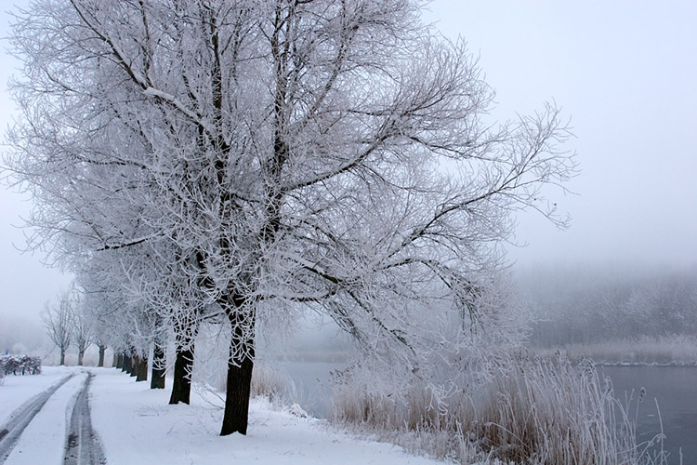  [Dutch Dike in the Snow] | Today it was my turn to do the job. It was very cold, and a thick winter fog made visibility less then 100 yards. When I was in the Wiele, I went up to the railway track to check the snares in the meadows behind the railway track. Approaching the railway track I suddenly saw a three man patrol of the Grune Polizei with a Doberman Pincher dog. They seemed to appear out of nowhere. I was
Greatly shocked. Fortunately I saw them from behind, so they did not see me. There was no wind so the dog could not catch my smell. They walked in the direction of Lemmer.

I did not have much time to think what this rabble was doing over there at 10 o'clock in the morning. I walked backwards through the high snow to the Wiele. The railway track runs right behind the Wiele. As soon as I could not se the nazi's anymore, and they could not see me either, I ran as fast I could in the opposite direction. I did not care anymore about the snares behind the railway track and left the snares unchecked. With a hare over my shoulder I ran around a large detour towards Lemmer. Watching carefully left and right, being alert for another patrol. Walking by way of a frozen channel, I came home. If the nazi's had seen me, I would have been in big trouble. The Germans hate poaching. | 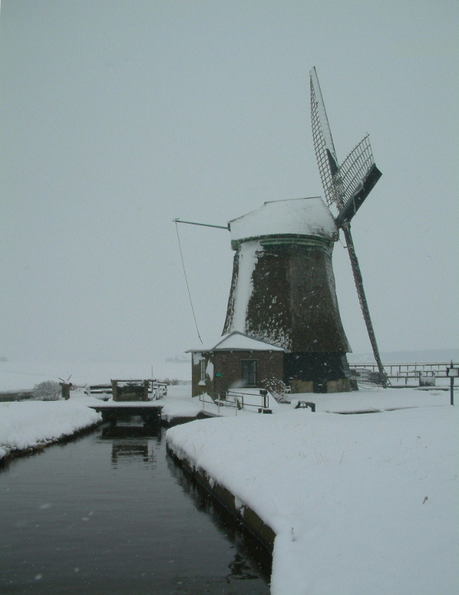

Saturday December 23rd.
My mother is not very happy with a new habit my Father has had the past few months. But before I explain that, I need to explain something else. In the central bakery of Lemmer there is a soup kitchen. In this soup kitchen the population of Lemmer can get meals of reasonable quality. The meal is mostly composed of potatoes, vegetables, and meat. The meat comes from the slaughtering of cattle or sheep that had an accident. We have never seen so many farm animals so accident prone, that they have to be killed and slaughtered. The most important thing is that the meat is not going to Germany, and is for the benefit of our people in Lemmer. and hungry people coming for food to Friesland.

Back to father's new habit. Because we manage to have enough food, we do not always use the coupons for the soup kitchen food. Father goes in the morning, as soon as curfew is over, to the boat that came from Amsterdam that night. He looks for the man or woman, who in his opinion is the one, who is in need of a good meal, and takes him or her home. Mother warms the meals on our stove, and gives it to the poor person. Mother, however, does not like this habit of father very much, because mother is afraid, that they might have lice or scabby. Father does not care about mother's worrying. He says we are created to help each other, most at all the ones in need. He keeps coming home with the one he calls the poor person of the day.

WAR MEMORIES 24
1944
Christmas December 25th.
Last week father went to Gaasterland to get a Christmas tree. It was not an easy ride for father, since he drove a bike with massive tires, and there was nearly a blizzard. The temperature was minus 8 degrees Celsius (About 17 degrees F) Out of the forest of Gaasterland he chopped a nice small fir tree, illegally. With the tree tied to his bike, he came home exhausted. From an old hoop and a few branches from the tree, my sister and I made a nice Christmas wreath. For decoration we used red wrapping paper left over from better times in the past. Among our Christmas decorations, we found some half burned candles. Together with the decorations and the candles, we made a reasonable looking Christmas tree out of the fir tree. Notwithstanding the miserable situation everywhere, we created in our house a pleasant atmosphere, so our fifth Christmas of the war did not look so cheerless, as it is in reality.

New Year's Eve, December 31st.
War year number five runs to its end. It is very cold outside with a lot of snow on the ground. In the western part of Holland, people die of starvation. Here in Friesland we can manage reasonably well as far as food in concerned. The ones who cannot collect enough food (old and sick people) get help from their family, neighbors or friends. There is not enough bread and it is barely edible. It looks like soft black clay. Mother bakes our own bread. The bread with the bran still in, tastes like cake from before the war.

Today Father baked oil balls (a kind of Dutch donuts). He traded a part of the gin he got for our last poached hare, for a liter of cooking oil. For the filling of the balls, he used chopped apples. The oil balls tasted delicious as long as they were still warm. As soon as the balls got cold, they were no longer edible. The oil he got was mixed with paraffin, and this mixture caused a strange while glossy layer on the balls, as soon as they got colder. Therefore, we only ate warm oil balls.

Mother probably was right when she said to father that some of father's poor guests could have scabby, because our whole family suffered from it last week. It causes itching all over the body. Our family doctor gave us some sulfur powder which cured us pretty quickly. Mother was very much ashamed, and did not dare tell anybody about the problem. It was not even her fault. According to our doctor you get the disease, when you touch somebody, who has the disease. She only has soda to wash our clothes, and must heat the water on our stove.

On the front lines everything is going well. The southern part of our country is liberated. The German Ardennes offensive is a failure. The Russians and Americans stay respectively at the East and West borders of the Third Reich. We are sure the year 1945 will be the end of the Germany, which was so powerful in 1939. Around Lemmer there are still signs with a death's head and the words "ACHTUNG MINEN" (Attention mines). Our village can still expect a thing or two with the coming liberation, but all will be revealed in good time.

1945
Tuesday January 9
Last night there was an awful accident on the Suider Sea. The Groningen IV, one of the boats that regularly sails between Lemmer and Amsterdam, sank. There were many people on board on their way to Friesland to gather food. Fortunately another boat (the Jan Nieveen) was not too far away and could rescue many passengers. However, many passengers drowned, especially the ones who hid from the Germans in the cargo hold.

Saturday January 13th.
Father went today to a farmer out in the countryside to trade some salt for meat, butter and cheese.
To be continued

[Chronology added for your reading convenience]

1944
January 6th - Soviets advance into Poland.
January 22nd - Allied landings in Anzio.
January 27th - End of siege of Leningrad.
March 19th - Hungary occupied by German Army.
May 9th - Sevastopol falls to Soviets.
June 4th - Rome captured by Allies.
June 6th - Operation Neptune/Overlord - Allied invasion of Normandy.
June 27th - US Army captures Cherbourg.
July 3rd - Soviets re-capture Minsk.
July 7th - Japanese defeat on Saipan.
July 9th - Allies capture Caen.
July 20th - German assassination attempt on Hitler fails.
July 21st - US landings on Guam.
July 25th - Beginning of Operation Cobra - Allied breakout from Normandy.
July 28th - Soviets take Brest-Litovsk.
August 4th - Allies liberate Florence.
August 15th - Operation Anvil - Allied landings in South of France.
August 25th - Allies liberate Paris.
August 28th - Liberation of Marseilles/Toulon.
August 30th - Germans abandon Bulgaria.
August 31st - Soviets capture Bucharest.
September 2nd - Pisa liberated.
September 3rd - Antwerp/Brussels liberated.
September 5th - Soviets declare war on Bulgaria.
September 12th - Le Havre liberated.
September 17th - Operation Market Garden - failed airborne assault in Holland.
September 22nd - Boulogne liberated.
September 26th - Estonia occupied by Soviets.
September 28th - Liberation of Calais.
October 1st - Soviets enter Yugoslavia.
October 4th - Allies land in Greece.
October 14th - Athens liberated.
October 20th - Liberation of Belgrade.
October 21st - Allies capture Aachen.
October 23rd - Soviets enter East Prussia.
November 24th - French capture Strasbourg.
December 16th - German attack through Ardennes - Battle of the Bulge begins.
December 26th - US troops hold Bastogne - Ardennes offensive stalls.
WAR MEMORIES 25
1945
Saturday January 13
The farmer, with whom father was trading, was very happy, because he had just slaughtered a pig illegally. When father was satisfied with the deal, and was about to go home, the farmer offered a side of bacon, if father would bring two hams to a fish smoker in Lemmer named Weiro Sterk. Father knows Wiero Sterk quite well, because he is the man, who bought father's fish factory before the war, during the depression time. Even though there was a chance of being arrested by the Grune Polizei on his way back home, he took the risk. If you are arrested by the GP, and they find 2 hams, they will send you to prison, at least. When father got home without being arrested, he immediately went to Wiero Sterk with the two hams. Wiero Sterk said: "I know nothing about hams." He refused to accept the hams. What to do now? Father did not remember exactly where the ham farmer lived, and did not want to take the risk of traveling with two hams for a second time. After a long conversation about what to do, father and mother decided to accept the hams as a gift from the Good Lord, and to divide the hams within the family.

Sunday February 18th.
We got a visit today from Geri Boon, the girl from Amsterdam that last October slept in our house. She had ridden a bike without tires via the dike that shuts off the Suider Sea, from Amsterdam to Follega, 2 miles east of Lemmer. With church help, she got into a temporary home with a farmer. Life in Amsterdam gets more and more impossible day by day. Many people have died of starvation in Amsterdam. Geri's parents could use Geri's ration coupons, so they have a little bit more to eat. Geri promised that she would come to visit us on Sundays, when she was free. I think she is a nice girl.

Saturday March 17th
Next to farmer Hoekstra, where our family goes twice a week for milk, two members of the Wasserschutzpolizei (water police) from Lemmer have been shot to death by the Dutch secret army. What exactly happened, I do not know, but the Nazi's will surely take their usual steps.

In February 1943, two operatives of a Dutch resistance cell called CS-6 (for their address, 6 Corelli Street, in Amsterdam) rang the doorbell of 70-year-old retired Lieutenant-General Hendrik A. Seyffardt in the Hague. After he answered and identified himself, they shot him twice in the abdomen. He died a day later. This assassination of a lower-level official triggered a cruel reprisal from SS General Hanns Albin Rauter, the killing of 50 Dutch hostages and a series of raids on Dutch universities. By accident the Dutch resistance attacked Rauter's car on March 6, 1945, which in turn led to the killings at De Woeste Hoeve, where 116 men were rounded up and executed at the site of the ambush and another 147 Gestapo prisoners executed elsewhere. A similar war crime happened on October 1 and 2, 1944, in the village of Putten, where over 600 men were deported to camps to be killed in retaliation for resistance activity.

Sunday March 18th.
At Doniaga between Follega and St. Nicolaasga, was as reprisal for the killing of the two members of the Wasserchutzpolizei. 10 innocent civilians were killed by the SD. (German security service). The bodies of the innocent victims had to remain in the edge of the nearby road for 24 hours. This as an example for what the Nazi's call Dutch terrorists. The farm where the sailors were killed was burned down by the SD. The cattle of the farmer were taken away for the German army and navy. The farmer and his family escaped in time.

Postum is an instant type beverage used in place of coffee. It reached the height of its popularity during World War II. Postum is a powdered coffee substitute sold by the Kraft Foods company. It's a kind of roasted grain beverage. The caffeine-free beverage mix was originally created by company founder C. W. Post in 1895 and marketed as a healthy alternative to coffee. Post was a Seventh-day Adventist and a student of Dr. John Harvey Kellogg who felt caffeine was unhealthy, and thus created an alternative of mostly wheat and molasses. Postum is still available, although it is now marketed by Kraft Foods. Postum is still popular among those who believe coffee to be unhealthy, or who avoid caffeinated beverages for religious reasons, such as Mormons. The ingredients in Postum are wheat bran, wheat, molasses, and corn dextrin.

Monday March 19th.
This afternoon about 5 PM we were drinking substitute coffee together in the kitchen, when mother said: "Be quiet, I hear something in the living room."

Father took a look, but came back without having seen anything or anybody. We were just sitting around the dinner table again, when we all heard a noise. Again father took a look and came back immediately with a frightened stranger.

The man said in poor German: "Ich Polak, ich habe angst fur Deutsche." (I am Polish, I am afraid of the Germans).

Father went back to the living room to look through the lace curtains at what was going on in the street. There he saw several members of the Grune Polizei with their rifles at the ready. What to do? Hiding the Pole in the shelter under the living room floor, could take too much time. The only solution was to take the Pole through the back yards to Park street.
To be continued.

WAR MEMORIES 26
Monday March 19th
In German, I told the man how he had to go, and where he could hide himself to escape from the krauts. It was impossible for him to go through the meadows behind our street, because he could be seen by the search light posted at our graveyard. I was just back home when the Grunen (Green ones) tore into our house.

In the typical German way, they asked us: "Wo ist der Polak?" (Where is the Pole?)

We said we had not seen a Polak, but they did not believe us. They noisily searched our home. They did not look under the carpet, where the entrance (hatch) is to the hiding place under the floor. If we had had time enough to hide the Pole there, he would have been relatively safe. Besides one can creep under the floor to the house next our house. There are small apertures in the foundations under the houses. After carefully searching our home, the Grunen went to the house of our family next door. The house of our family and our house have a joint porch and from the street, when you are not right in front of the house, you cannot see where somebody went in. My uncle and aunt did not know anything about what was going on and became very upset, when those dirty fellows acted so terrible in their house.

When they did not find anything at my family's house either, they went through an alley next to the houses to the back yards to check the gardens. Fortunately the Pole was gone already, and nowhere to be seen anymore. I am sure they did not catch the Pole because later on, when I checked the bushes between the two Park-streets, I discovered nothing. I do not know where the Pole went. He probably got help from other people. One does not talk about this kind of thing.

After this happened, it was six PM already, and we were sitting around the table to talk about it. A man rang on our front door and introduced himself as Jan Boon, Geri's father, (Geri who worked at a farmer's). He told us that he had come overland from Amsterdam via Zwolle to Follega, to see how his daughter was doing. He also wanted to thank us, for the way my parents had helped Geri, when she came to Friesland. He did not know how to go back to Amsterdam, because the Yssel river bridge for all civilian traffic was closed. Mr. Boon told us that when he was a couple of blocks away, he had seen a couple of Germans firing at a man who fled into our street. He did not dare to go down our street. He waited until everything was quiet again. Mr. Boon must have been a witness of what happened right before the Pole fled into our house.

Tuesday March 20th
Mr. Boon spent the night in our house, and said he slept well. Father got a ticket this morning for the Jan Nieveen, thanks to father's connection with the staff of the boat company. The Jan Nieveen is leaving tonight for Amsterdam. Mr. Boon got a bag of potatoes, some rye and wheat from my parents, and was very happy with this food. From the farmer where Geri works, he could buy butter and cheese. If the krauts do not take it away from him when he arrives in Amsterdam, the Boon family can live on it for some time. Mr. Boon's bike can not go on board, so he left it behind for Geri. From Mr. Boon we learned the situation in Amsterdam is hopeless. It is very important that Mr. Boon arrives safely in Amsterdam with the food.

Friday March 23rd.
I have not written about the following subject yet. Father has forbidden me to do so, because he was afraid that if the Germans eventually got my diary in their possession, this would have terrible consequences for father, young men that went in hiding, and the families where these young people were hiding. Here follows the story. At least twice a month a young man, between 18 and 25 years old, comes to our house with the code words: "This is not the Feenstra family written as Veenstra with a V is it?"
To be continued

From Wikipedia:
Resistance in the Netherlands took the form of small-scale, decentralized cells engaged in independent activities. Some small groups had absolutely no links to others. These groups produced forged ration cards and counterfeit money, collected intelligence, published underground newspapers, sabotaged phone lines and railroads, prepared maps, and distributed food and goods.
One of the riskiest activities was hiding and sheltering refugees and enemies of the Nazi regime, Jewish families like the family of Anne Frank, underground operatives, draft-age Dutch, and others. Collectively these people were known as onderduikers ('people in hiding' or literally: 'under-divers'). Later in the war this system of people-hiding was used to protect downed Allied airmen. Reportedly resistance doctors in Heerlen concealed an entire hospital floor from German troops[citation needed].

WAR MEMORIES 27
Friday March 23rd
By this father knows that the young man probably comes from Amsterdam or from another large city in the Western part of the Netherlands for a hiding place somewhere in Friesland. From a member of the underground army, father gets an address where the man must go. Often this is the hiding place, but it is also possible that this is a temporary place before moving further. Father used to do the job himself when he still had an "AUSWEIS" (permission paper) from the Friesland watermill. When the Germans closed the watermill, father's AUSWEIS was taken away. Now it is too dangerous for father to travel with a young man. After a serious conversation between my father and me, I took over this job.

When I have to take somebody some place, I go by bike ahead of the man. I go at such a distance, that he can still see me. If the Grune Polizei should patrol somewhere, they make me stop near them, and the person behind me is far enough away to hide between trees or somewhere else. My excuse to the Grune Polizei is always that I am trying to get milk from a farmer. Therefore I always have two empty bottles in a basket on back of my bike. I must have been born under a lucky star, because so far, I never had to stop for a check during my underground task, which I find very exciting.

Today I got stopped near a bridge over a canal in Follega. I must confess that I was rather nervous, because I am sixteen years old, and they can take you along for working on their defense projects. I think that my reasonably good German helped me, because I was allowed to go on. The person I was escorting, went to a farmer who helped him to wait for my return. Before we leave, the person has to learn by heart, exactly the farmer's house numbers where he may not go. On this occasion there were only two farmers who we could not trust 100%. I saw where the person went, and when I came back about an hour later, the Grune Polizei were gone, and I could lead the man to his destination. I am never told the name of the person, or where he came from. The motto is; what you do not know, you cannot tell.

Germany, before the Nazi take-over in January 1933, had a normal police force - Die Polizei - divided in the Ordnungspolizei(= Order Police) doing street duties, directing traffic and maintaining law and order - dressed in green uniforms they were also known as the Grune Polizei or Green Police - and the Kriminalpolizei or Kripo, the normal criminal investigation department. Added were
- the Sicherheitspolizei or Sipo (= Security Police) in charge of the state's security.
- the Geheime Staats Poilizei or Gestapo (Secret State Police) controling the people

from http://www.scoutmaster.ru/ru/hist/pk_und2_est.htm

Saturday March 24th.
There is again movement towards our liberation. English, American and Canadian troops have crossed the Rhine River East of Nijmegen. Airborne troops have landed on the North side of the Rhine river between Wesel and Bocholt, both cities in Germany. Those cities are not too far away from the border between Germany and the Netherlands. It is very dangerous now, to be on the road. The sky is constantly full of allied planes, mostly fighter-bombers to hinder the Germans in their movements. The planes shoot at everything that is moving. Only a single person can still go along the roads, and even then, still has to be careful. The road between Lemmer and Sneek is constantly under allied air patrol too. On what mobile transportation the Germans still have, they have a soldier sitting on one of the front splash-boards of the vehicle, looking for Tief flieger (planes flying at low altitude) As soon as they hear or spot a plane, they leave the car as it is, and dive in a one man hole, dug along every road. The Germans have also small brooms tied before the front car wheels. They do this to prevent flat tires. Our underground army has dropped at various places, what we call crow-paws.

Operation Varsity - The Rhine Crossing.
The biggest and most successful airborne operation in history marked the beginning of the end for Germany, as Allied airborne troops mounted the final barrier and crossed the Rhine. In total, six parachute battalions, including the Canadians, of the 6th Airborne division, supported by glider troops from the Air Landing Brigade, dropped on March 24, 1945, as a complete force. Together with the US 17th Airborne Division, the aim of the operation was to secure and deepen the bridgehead cast of the Rhine and then advance across country to the Baltic coast, 350 miles away. The Germans expected the invasion, and fighting on the DZs (Drop Zones) was heavy. Weather for the drop was perfect and almost everyone landed on their respective DZ, although some ended up in the trees and were cut down by German machine guns as they fought to free themselves. The 5th Parachute Brigade suffered heavily from casualties as mortar fire exploded in the skies around them during the drop. On the ground the enemy had occupied almost all of the nearby houses, but by late afternoon, the Brigade’s three Battalions had cleared them. Within 24 hours, all objectives for the brigade had been achieved and as planned, the division was joined by ground forces of the 21st Army Group, for the advance across Germany. The bridges over the river were secured 'and the village of Hamminkeln captured, all objectives had been achieved within 24 hours. From http://www.army.mod.uk/para/history/rhine.htm

Wednesday April 4th
Geri Boon came from Follega to ask if I could take her to the Christian High School. Someone had told her, that her brother Jan and many more children from Amsterdam have taken shelter in this school, waiting for transportation to a family, where they could spend the rest of the war. When we got to the school, Geri's brother Jan stood outside the school waiting for his sister. Jan told us, that they had waited in Amsterdam (from Good Friday till Tuesday after Easter) on board the boat because the weather was too bad to cross the Suider Sea. A few kilometers before the harbor entrance of Lemmer planes dived at the boats with the children. The escort people waved red-cross flags and the planes disappeared without shooting. Jan did not know where they would take him. As soon as he knows, he will write his sister. To be continued.
WAR MEMORIES 28
Wednesday April 4th
The children from Amsterdam did not get proper food during the last two days. They lived off cooked potato peelings. They were very hungry. After arriving in Lemmer, the children got warm milk, porridge and sandwiches. Their hunger faded away.

Friday April 6th
Starting today, we have a guest in our house. Geri Boon, who has been living with a farmer in Follega, could no longer stay there. The farmer is a nice friendly man, but his wife is different. The farmer's wife is the one with whom Geri has to deal. When Geri was writing a letter to her parents, Geri had to go outside. Geri left the letter on the table. When Geri came back into the room, the farmer's wife was reading the letter. This led to an argument between the two, and now Geri tries to go back to Amsterdam with a German naval boat. A woman from Amsterdam visits the farmer now and then. This woman said that she could manage a trip back home for Geri. Geri came to say goodbye.

My mother did not want a seventeen year old girl to travel by night back to Amsterdam over sea with a bunch of young krauts. Mother decided that Geri had to stay with us till the end of the war. This war will not last much longer, and where there is food for four people, there will be food for five people too. My sister was told to assist Geri in getting her personal belongings from the farmer's home back to our home. This was done.

Tuesday April 10th.
It is obvious that German Soldiers are coming to Lemmer from all directions. They are no longer the proud soldiers of a well-disciplined army. It looks more like a disorderly flight. Instead of coming by car or tanks, as they did in May 1940, the Germans are now coming by foot and on stolen bikes. They come also on stolen farmers' carts. The carts are loaded with stolen food. I even saw a cart with a pig on top and a cow tied behind. Is the German army, which was once so famous, who conquered the whole of Europe, on the run for good? But where are they heading? They are not going in the direction of their Heimat. Rumors are going around, that in the eastern part of Friesland allied paratroopers have landed, and that could be the reason they are making a detour to their Heimat.

During World War II, Operation Amherst was a Free French SAS attack designed to capture intact Dutch canals, bridges and airfields.

The operation began with the paradrop of seven hundred Special Air Service troopers of 3 and 4 SAS (French) on the night of the 7 April 1945. The teams spread out to capture and protect key facilities from the Germans. Advancing Canadian troops of the 8th Reconnaissance Regiment quickly relieved the isolated French SAS.

The majority of the French paratroopers were dropped over the North-western part of the province of Drenthe. Here they managed to occupy a series of bridges and conducted hit and run attacks on the withdrawing German troops. A small group of paratroopers under the command of Captain Henri Sicaud were dropped in south-east Friesland close to the border of Drenthe. Under the cover of heavy clouds several sticks consisting of approximately 10 paratroopers each managed to land without being detected by the Germans. Captain Sicaud, however, landed in a pine tree and his eye was pierced by a branch seriously limiting the use of his eye. Some of the French paratroopers were discovered by a band of Dutch resistance fighters who had made their shelter in the vast forests south of the small village of Appelscha. Led by an agent of the Dutch government in excile in England, the paratroopers managed to re-group and start a series of attacks on German troops retreating through the area to Germany. Sicaud and his paratroopers managed to occupy an important bridge, seriously frustrating German troop movements. A series of running battles between the French, the Germans and Dutch nazi collaborators were conducted near the bridge.The civilian population of Appelscha, after a relatively calm five years of German occupation, were drawn into five days of heavy fighting leaving no civilian casualties but plenty of German dead.

One group of paratroopers were dropped too far from Captain Sicaud and ended up in the outskirts of the small village of Haulerwijk, ten kilometers north of Appelscha. German troops discovered the French in the early morning of the 8th April and a fire fight broke out between the French and the Germans. One French SAS trooper was killed, whilst some of the French were captured and some managed to flee and catch up with the French fighting in and around Appelscha.

http://en.wikipedia.org/wiki/Operation_Amherst

Friday April 13th.
The rumors about paratroopers landing in eastern part of our province are true. In the night 7/8 April, French paratroopers were dropped near main bridges and crossroads, to prevent the Germans from blowing up those bridges and mining the roads, so they cannot delay the rapid advance of the allied troops. In the meantime hundreds, perhaps thousands German troops went through our village. What a different impression the soldiers make compared with the ones of the proud German army, that on the 10th of May, 1940, almost 5 years ago, showed us their apparent invincibility. Around our village the Germans are blowing up most of the highway and railway bridges. As far as we know only a few bridges they use for their troops are still OK.

Saturday April 14th.
Father and I were doing springtime work in our vegetable garden north of Lemmer, when father's brother, Uncle Peter, came there very excited with the message; we had to come home right away. About five miles south of Lemmer, English soldiers were fighting with German soldiers for the bridge over the Tjonger river that was still not blown up. A town called Wolvega in the same direction was liberated already, and Heerenveen 15 miles east of us, is taken by allied troops too. We hardly could believe this fantastic news, but the message made us very happy, and we went home with my uncle.

WAR MEMORIES 29
Sunday April 15th
My friends and I took a short walk into the direction from where we expected our liberators. We could hear to the east the noise of heavy engines. We supposed the noise we heard was of the tanks of our liberators. We have not heard such noise since the German army invaded us in 1940. We got exited at hearing this noise. People told us there is fighting in three places around Lemmer. We heard explosions now and then. The explosions can have different reasons. German soldiers are still blowing up important buildings and bridges or they could be artillery shells. We are sure our liberation will not take much time now. One can feel the liberation hanging in the air, and there is a tense atmosphere all around. Back in our village, we saw the remainder of the Nazis. Our street is crowded with all types of vehicles; mostly stolen farmer carts. This army cannot stop our liberation. Everybody is convinced of this fact.

About six o'clock in the evening an old German soldier came to our back door. I suppose he was in his sixties. The man asked if he could get some water to drink. All day long he had had nothing to eat or to drink. The German was dressed in a uniform jacket, a pair of dark civilian trousers and military boots. Mother felt sorry for the man and asked him to come inside. Mother cooked some baked potatoes for him. She gave him a glass of warm milk. The soldier was very thankful, and told us that three weeks ago, he was still working in a factory in Germany. He was inducted into the army for the second time in his life. He was very afraid, and did not know where his superiors would take him. One thing he knew for sure, this war would end soon. The tommies were near by, between 6 and 10 miles from here. Every day he was praying for survival as he also did in WW-I. At first, I was shocked and mad at mother, when she gave a dirty kraut food and milk, but after the kraut told us that the tommies were so close, I was no longer mad at her for helping the enemy.

Monday April 16th.
Our village is crowded with German soldiers. There are some Dutch SS-ers among them too. The street where we live is over loaded with military vehicles. It is even difficult to cross the street from one side to the other. This afternoon at 4 PM, I went along a railway track, (no longer in use since the Dutch Railway Company went on strike September 5th last year), to a farmer's where we buy milk illegally. The weather was beautiful for this time of the year, and many farmers had their cows outside already. My father's sister was buying milk from the same farmer as I did. We had bottles with us to put the milk in. As soon as the bottles were filled with milk, my aunt and I went back home the same way we came.

While we were walking home, we heard heavy explosions in the east. The explosions were much louder than before. I told my aunt that those explosions probably were exploding shells. A member of the Dutch secret army told me that there is heavy fighting going on since yesterday near a bridge over a canal on the road from Sneek to Lemmer. It is clear, our liberators come from different directions towards Lemmer trying to liberate us. It is also clear, that the krauts are not giving up easily. My aunt got scared at the explosions and urged me to run faster, even though she is almost 60 years old.

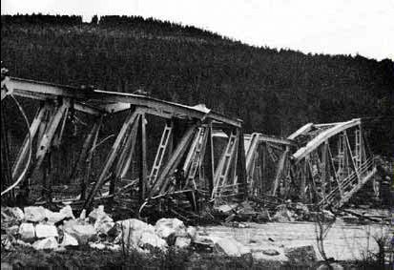
[Right time period I think - right continent I think - do not know the bridge]

After coming home, father told me that heavy fighting was also going on for the bridge over the Tjonge river, south of us. In the evening at 5:30, there was violent pounding on our front door. Father opened up and right away a young kraut yelled to him: "Er sol sofort das Pferd besser einspannen". Father does not know how to do such a thing. He got busy with ropes, trying to get the horse tied for the vehicle. We hoped father did a good job, because otherwise the young kraut could accuse him of sabotage, and then shoot him.
To be continued.

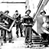 | [Grainy picture of German soldiers looting a museum]

WAR MEMORIES 30
Monday April 16th
When Father came back, we peeked through the curtains, and after a while saw the kraut with vehicle and horse going away. Father has put boards on our basement floor, for expects the fight for Lemmer will start tonight or tomorrow. As soon as the fight starts, we will put mattresses on top of the boards, so we have a little bit of comfort. Since we no longer have electricity or candles, we went to bed early, as we have been doing a lot lately.

Just as we were in bed, around 9 PM, we heard a screeching noise, followed by several explosions. Our house was shaking on its foundation. My mother and sister ran as fast as they could down stairs. Father, Geri and I followed more calmly. Downstairs father and I went outdoors to find out what was going on. Our street was empty, no longer a kraut to see. In the other streets we heard Germans yelling commands. Since we had not heard planes this evening, we concluded that bombs did not cause the noise of explosions, but a couple of shells are fired on our village. Since apart for the yelling krauts, every thing was quiet again, we went to bed for the second time that night.

We were just stretched out, when once more we heard a screeching noise followed by loud explosions. Our house was shaking again. Right away father, mother and my sister ran down stairs. Geri and I first looked through the window of her bedroom on the eastside of our house to see if we could see something. We saw nothing and then we went to my bedroom on the west side and looked out. In the distance it looked as if the whole village was on fire. Mother urged us to come down immediately. Because we were frightened by what we saw, Geri and I obeyed my mother's call to come downstairs right away. In the living room the whole window was blown out. The curtains were waving in and out. In the distance we heard crying Muti, Muti.. For sure, this was a young kraut, which had shit in his pants or was wounded.

We got the mattresses from upstairs and spread them over the boards on the basement floor. We knew that this way, we would have a little bit of safety against the violence that had started. In the mean time shells screeched over and exploded again in the direction of the harbor. After a while we knew that the shells were fired with an interval of about 15 minutes. If we were listening, we even could hear the guns firing. When we did not hear the screeching, the shells exploded rather close to our house. We did not know exactly where. Increasingly we got used to the situation. I even fell asleep and when I was awakened again by nearby explosions, I found that Geri had chosen a sleeping spot close to me. The shelling went on the whole night and we all were very frightened.

Tuesday April 17th
The shelling stopped at 4 AM this morning. It was quiet and peaceful outside. Right after the shelling stopped, I fell asleep. At 7 AM I woke up. I was stiff due to the difficult way I had been laying in our basement. I quickly went out of the basement to freshen myself. Mother said that she had not been able to sleep anymore after the shelling stopped. She left the basement at 6 AM, and had prepared breakfast, and made a pot of imitation coffee. We have almost forgotten how real coffee tasted. The hot imitation coffee, and a few slices of home baked wheat bread made me feel a lot better.

Father went early this morning to check how his mother was doing. When he got home, he told us that his mother and his unmarried sister had an awful night. A shell exploded close to their front door. All the windows, the door, and a part of the house were blown away. My grandmother and aunt were reasonably well. They really must have had an awful night. Fortunately they were not wounded, but just shocked. Most houses in the street where they live were damaged. Red Cross people were taking care of the wounded. Dead victims were brought to the mortuary. Father had not seen him, but an acquaintance told father that mother's brother, Uncle Luke, had a wound on his back caused by shrapnel.

[Later he mentions the damage near the harbor. Below is a picture of the town quay of Lemmer taken recently. Looks like they fixed it. ☺]

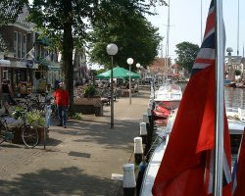

WAR MEMORIES 31
Tuesday April 17th.
There are no krauts in Lemmer anymore. Without fighting, the Germans left our village. They sure were afraid of the Canadian fire power. The krauts fled by boat, and took their dead and wounded with them to the other side of the Suidersea. They have closed off our harbor entrance by sinking several boats. Most of their vehicles they pushed into the water. There is a terrible chaos in Lemmer everywhere. So far, the allied soldiers are not here yet. Men of the Dutch secret army keep order in the streets. They wear as a uniform a blue overall and are armed with sten-guns. The sten-guns were dropped by night during the last year of German occupation.

For me it was about time to check how our house had done during the shelling. The windows were all broken and at several places, there were holes, caused by shrapnel. That our house had no more damage than that, we thank the high trees, not too far way from our house. The tops of all the trees were gone. The shells probably exploded in the treetops and therefore did not hit our house.

Most of the chaos was around the harbor. Destroyed anti-aircraft guns stood on the harbor quay. I found a beautiful pair of looking glasses made by Zeiss. I took this war loot home, of course. One or more shells had hit a German ammo depot, and unused ammunition of all sizes laid spread around. After all, I found the damage not as bad as I had expected, thinking of the many shells, which had fallen during the night. A dozen krauts had hidden themselves and are now captured as POW by the Dutch secret army. These krauts had enough of the war and surrendered. After a while, every house put out our national flag Red, White, and Blue. Everyone is happy, even though there are victims in many families.

Our friend in the secret army told us that the liberators could not come yet. Their engineers have to fix a bridge over a canal 2 miles east of us first. My friends and I walked towards the place where the engineers have to build a bridge. About one mile outside the village, we saw the first allied soldiers. The soldiers ran one after the other. They wore kaki colored uniforms of a completely different design than the Germans were wearing. Their helmets were a flat design with a brim around. Most of the soldiers were armed with a rifle, but in every platoon was a soldier with a machine gun. They smiled at the people who came to meet and cheer our liberators. The soldiers gave us cigarettes and chewing gum. We started to talk to them.

They told us they were French Canadians and when they spoke to each other, it was in French. My school English is reasonable after 4 years High School, but my French is still not too good. One of my friends could do better in French. The nearer we came to our village the more people came out cheering the Canadians.

When we came to the first houses, I heard one of the soldiers say in the microphone of his little radio: "Here X-ray Pappa One, Here X-ray Pappa one over." Then for a moment he said nothing and then continued saying: "We are in the outskirts of a town called Lemmer. People say there are no more gerries here, but what I see is a lot of beautiful young girls, over and out."

While walking with the Canadians, they told us that they belonged to the Le Regiment de la Chaudiere. They were a reconnaissance platoon. The main force would come as soon as the bridge over the canal was ready. In the afternoon more and more troops arrived in Lemmer. Many of them came with what they called carriers. Our neighbor's became billeting for two Canadian soldiers. Our house was too small with five inhabitants in it already. How differently these Canadians acted in comparison with the Germans in 1940. The Canadians leave their weapons unguarded behind in their room, and make fun with the local people, especially with the girls. The Germans at the time never let one of their weapons unguarded. After all, the Germans were our enemies, and we hated them, while the Canadians are our friends, and we love them.
To be continued.

Le Régiment de la Chaudière is a reserve infantry regiment of the Canadian Armed Forces.
The regimental ensignia consists of two crossed machine guns, surmounted by a beaver supporting a fleur-de-lys. Under this is a scroll inscribed with the device 'Aere perennis', with a small maple leaf on each end.  Le Régiment de la Chaudière was formed following the fusion of the Regiments of Dorchester and Beauce on the 15th of December, 1936. The regiment was sent to England in August 1941, but would see no action until the D-Day landings of June 1944. Le Régiment de la Chaudière came ashore at Bernières-sur-Mer after The Queen's Own Rifles of Canada, surprising the locals who hadn't expected to find francophone troops in the liberating forces. | 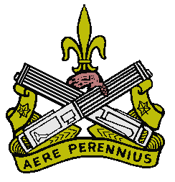
It would be the only francophone unit to participate in Operation Overlord with the Commando Kieffer. The regiment also participated in actions which took place on the Breskens peninsula between the 6th of October and the 3rd of November 1944.
On January 8, 1945, the battle of Leuth began. The region was swarming with enemy. Finally, after intense fighting and a great deal of sacrifice, the village of Hollen was liberated on
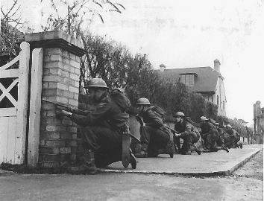 | January 26. The month of March was also marked by battle and glory; let it suffice to mention places such as the Forest of Hochwald, Emmerick, Hoch and Elten. During the last month of the war in Europe, Le Régiment de la Chaudière fought in many battles that deserve to be highlighted and which allowed the allies to wipe out the last pockets of German resistance. Indeed, the Regiment cleared the north of Holland and thrust into Germany to Grossefehn towards Aurich with the intention of attacking Emden from the rear.
WAR MEMORIES 32
Wednesday April 18th
What a wonderful feeling it is to go around as free people again. After almost five years of German occupation, nazi police and Dutch collaborators no longer control us. In the streets you see people who had to hide themselves for a long, long time. The Canadians gave away chocolate, chewing gum and perfect cigarettes like Players, Woodbine, Sweet corporal etc. etc. It is one great festival in our village. There is music everywhere and people are dancing together with the Canadians in the streets. The music is of a kind we have not heard in public during the last five years. There are new songs like In the Mood, We'll Meet Again, The White Rocks of Dover, Good Night Where Ever You Are Etc.

Early this morning there was a bit of tension among us. A German warship was sailing not too far out off the coast. People were afraid the boat planned to shoot at Lemmer with its cannons. The Canadians were prepared to answer any shooting. They have put heavy guns in position along the coast. We all were glad that nothing happened.

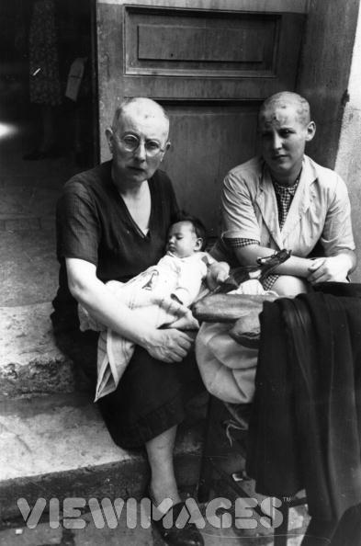  [Shaved collaborators. Not sure if they are Dutch or French or what.] | In front of our town hall, captured collaborators and girls who had been on familiar terms with the Germans got shorn bald. When the headmaster, of our high school, which was a kind of collaborator too, was taken to be shorn, I walked away, because the spectacle hurt me somewhat. After all, he taught me five years in bookkeeping. A year ago when we ran out of foot wear and father complained about my problem, I got a brand new pair of shoes from him. The shoes probably belonged to his son who was killed at the eastern front in service of the Dutch SS legion. First I refused to wear shoes of an SS man, but since I had nothing else, I finally gave in and accepted the SS footwear. However, I never told my friends how I got new shoes.

Today a Canadian flamethrower gave a show. The carrier came at top speed toward the harbor quay, stopped at less than two yards from the edge of the quay and spit a bundle of flames over the harbor water. It was a spectacular sight. Some Canadian soldiers are fishing with hand grenades. They let a grenade explode in the water, and then they have plenty of fish. They take the big ones, prepare and bake them. This is a kind of self support.
The End

Here follows the reason for my sudden stop. I tried to take apart a German anti-aircraft shell. I found the shell near the German ammo depot that had been destroyed. It is difficult to describe exactly how I took the shell apart, but anyway a small part of the shell, namely the front ignition, exploded in my left hand, and blew off the top of my thumb, my index finger, my middle finder, and my ring finger. The skin inside both hands was burned away and my face was bleeding from all the small shrapnel pieces, which hit my face. I was brought to a nearby hospital, and had to stay there for two weeks. Many people visited me. I regret I was not able to write more about the liberation, but after all the war was over, and we had to go back to school, and study a lot. I will, as soon as I can, give some details about facts in my diary, but about which I gave no details during the war.

Wiebe

[Chronology added for your reading convenience]

1945
January 1st - Germans withdraw from Ardennes.
January 16th - German Ardennes "Bulge" eliminated.
January 17th - Soviets capture Warsaw.
January 26th - Japanese retreat to Chinese coast.
January 26th - Soviets liberate Auschwitz.
February 4th - Manila falls to Allies.
February 19th - US landings on Iwo Jima.
February 20th - Saarbrucken captured by Allies.
February 20th - Danzig captured by Soviets.
April 1st - US invades Okinawa.
April 10th - Hanover falls to Allies.
April 12th - US President Roosevelt dies - Truman becomes President.
April 13th - Soviets capture Vienna.
April 15th - Allies capture Arnhem.
April 23rd - Soviets enter Berlin.
April 20th - Nuremburg falls to Allies.
April 28th - Mussolini captured by partisans and executed.
April 30th - Hitler commits suicide.
May 2nd - German forces in Italy surrender.
May 4th - German forces in Holland, Denmark and N W Germany surrender.
May 5th - Ceasefire on Western Front.
May 7th - German unconditional surrender.
May 8th - VE Day declared.
June 10th - Australians invade Borneo.
June 22nd - US forces capture Okinawa.
August 6th - Atomic bomb dropped on Hiroshima.
August 8th - Soviets declare war on Japan.
August 9th - Atomic bomb dropped on Nagasaki.
August 14th - Japanese surrender.
August 15th - VJ Day declared.
September 5th - British land in Singapore.
September 9th - Surrender of remaining Japanese forces in China.
September 16th - Japanese surrender in Hong Kong.

[This needs an epilogue very badly. What happened to all these people?

Wiebe Feenstra [I did learn he had a career in the Dutch air force as an adult]
Wiebe's parents, and his sister
Grandmother Feenstra
Uncle Harry and Aunt Anna
Cousin Rita (Rina) and husband Andy (Anne)
Jake (Sake) & Betsie
Aunt Alice
Uncle Peter (Pieter)
Uncle Luke (Leeuwke)
Cousins George (Cor) and Minnie (Minne)
William (Willem) Gaasbeek
Jan Tenk
Geri Boon and her family - I did learn that Weibe and Geri were married and that she died a few years ago.
Paul (Paul) de Rook
Jim (Jilling) Kingma
Frank (Franke) Bootsma

Can I please have five or ten sentences about each one with regards to their life after the war?

Also, some pictures of them, then and now, would really make this much better.

I found a genealogy site on the web
http://www.spanvis.nl/stambomen.html
that has some of the surnames above and some pictures of pre WWII Lemmer. If they had some English labels some of them would make a very nice addition to the story. One of the pictures even had the name Wiebe Feenstra in the description but it is from 1920 so I assume it is his father.

I would be happy to post this story, minus the copyrighted stuff I inserted, on my website.

Also, you might want to consider offering it to
http://www.bbc.co.uk/ww2peopleswar/
to add to their collection.

Thor Carden
PO Box 2093
Madison, TN 37116
USA
615 594 2269
November 9, 2007

I got verbal permission to post this on my web site but no additional info.

